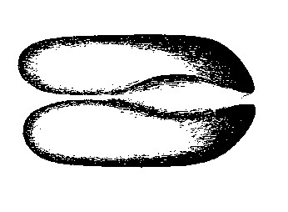
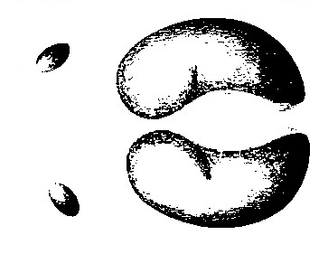
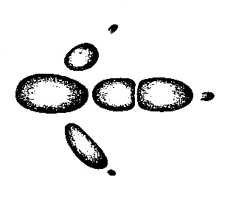
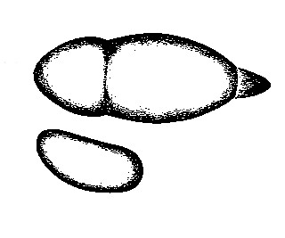

Madidi Lodge

The first night accommodation will be charged 100% on all cancellations made within less than 24 hrs of arrival
Room hire and all meals will be charged 100% on all no shows and cancellations made within less than 12 hrs
of the expected start of the meeting

