The <asp:checkbox> and <asp:checkboxlist> Controls
Checkboxes are similar to radio buttons, and in HTML, they were used to allow multiple choices from a group of buttons. With the <asp:checkboxlist> control it is possible to create them in groups, but unlike radio buttons, it isn't possible to restrict the user to selecting just one possible answer from a group of checkboxes: they can select as many as they like. The other fundamental difference between a checkbox and a radio button is that once you have selected a checkbox you are able to deselect it by clicking on it again.

We're not going to spend too long examining them, as most of the same principles that we followed in the <asp:radiobutton> and <asp:radiobuttonlist> examples apply.

A typical <asp:checkbox> looks like this:

<asp:checkbox id="check1" runat="server" />

If we want to use an array of checkboxes, we can contain them inside an <asp:checkboxlist> control. We need to set an id attribute for the <asp:checkboxlist> control itself, and create a <asp:listitem> control for each option inside the control:

<asp:checkboxlist id="check1" runat="server">
<asp:listitem id="option1" runat="server" value="Madrid" />
<asp:listitem id="option2" runat="server" value="Oslo" />
<asp:listitem id="option3" runat="server" value="Lisbon" />
</asp:checkboxlist>

Checkboxes are typically used when you have single yes/no answers, or you wish the user to be able to make a multiple set of selections, and be able to deselect them as well.

In our next exercise, we're going to tweak our previous example, so that it uses our established holiday code to allow the user to select more than one option for a particular destination.

Try It Out – Using the <asp:checkbox> Control
1. Open up the radiopage.aspx and amend the code highlighted in gray, as follows:
<script runat="server" language="C#">
void Page_Load()
{
string msg = "You have selected the following items:<br />";

if (check1.Items[0].Selected) {
msg = msg + check1.Items[0].Text + "<br />";
}
if (check1.Items[1].Selected) {
msg = msg + check1.Items[1].Text + "<br />";
}
if (check1.Items[2].Selected) {
msg = msg + check1.Items[2].Text + "<br />";
}

Message.Text = msg;
}
</script>
<html>
<head>
<title>Check Box List Example</title>
</head>
<body>
<asp:label id="Message" runat="server" />
<br /><br />
Which city do you wish to look at hotels for?
<br /><br />
<form runat="server">
<asp:checkboxlist id="check1" runat="server">
<asp:listitem id="option1" runat="server" value="Madrid" />
<asp:listitem id="option2" runat="server" value="Oslo" />
<asp:listitem id="option3" runat="server" value="Lisbon" />
</asp:checkboxlist>
<br /><br />
<input type="Submit">
</form>
</body>
</html>

2. Save this as checkpage.aspx.

3. Open checkpage.aspx in your browser, and select more than one option:

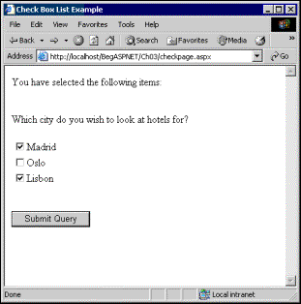

4. Then click on Submit Query:

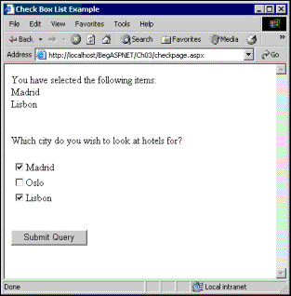

How It Works
Very little has changed with our control – all we've done is change the HTML control to an <asp:checkboxlist>, and then change the name of the control to reflect this:

<asp:checkboxlist id="check1" runat="server">
<asp:listitem id="option1" runat="server" value="Madrid" />
<asp:listitem id="option2" runat="server" value="Oslo" />
<asp:listitem id="option3" runat="server" value="Lisbon" />
</asp:checkboxlist>

Our ASP.NET code is the same as that we used for the listbox2.aspx example, earlier on, except that here it refers to a checkbox rather than a listbox:

string msg = "You have selected the following items:<br />";

if (check1.Items[0].Selected) {
msg = msg + check1.Items[0].Text + "<br />";
}
if (check1.Items[1].Selected) {
msg = msg + check1.Items[1].Text + "<br />";
}
if (check1.Items[2].Selected) {
msg = msg + check1.Items[2].Text + "<br />";
}

Message.Text = msg;

As you can see, checkboxes work in a slightly different way from radio buttons. Each time you add a value, rather than replacing it, the value is added to the contents of check1. However, for all other intents and purposes, you use them in the same way.

This operation will become clearer once you're familiar with Chapters 4 and 6 in which we deal with Data and Control Structures respectively.

One last point to note about checkboxes, though, is that you might want to treat each checkbox within a group as a separate entity, rather than have them all grouped together, in which case you could set all of them as separate <asp:checkbox> controls to reflect this:

<asp:checkbox id="check1" runat="server" Text="Madrid"/>
<asp:checkbox id="check2" runat="server" Text="Oslo"/>
<asp:checkbox id="check3" runat="server" Text ="Lisbon"/>

The text attribute here specifies the text that will appear next to the checkbox. The checkbox itself will not return a value. To find out whether it is checked or not we need to add some ASP.NET code to test if the Checked attribute is true or false: it will be true if the checkbox is checked.

Given that we've introduced a number of new concepts, in variables, we will stop here, as the subject of variables warrants a chapter in its own right. We've looked at the most basic server controls, and in order to make any more of them, we need to introduce new and more complex features

