CURRICULAM VITAE

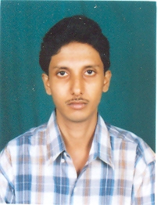
NAME : CHANDAN SHOME

FATHER'S NAME : NIHER RANJAN SHOME

PERMANENT ADDRESS : 48/A, NAZIR LANE,
KIDDERPORE,
KOLKATA – 700 023

CONTACT NO. : (R) 2489 2109; (M) 9433492833

DATE OF BIRTH : 12.07.1974

NATIONALITY : Indian

RELIGION : Hindu

EDUCATIONAL QUALIFICATION : Higher Secondary

OTHER'S QUALIFICATION : D.C.A. (Diploma in Computer Application)
(MS-Office, Internet, E-mail etc.)

WORKING EXPERIENCE : 4 years as a Secretary-cum-Computer
Operator with an Ex-Senior Forestry
Specialist (The World Bank)

10 years as a Receptionist-cum-
EPABX (Telephone) Operator in
Doctor’s Chamber

During 8 months as a Data Entry
Operator in Exquisite Consultants
Pvt Ltd. (Associated with Citi Bank)

----------------------

