SOURAV MITRA  B-16, BOGL Colony, Durgapur  PIN-713214  Mobile: +91-9732231189  Phone: +91-343-2503547  souravmca22@yahoo.co.in  sourav.mitra.mca07@gmail.com | 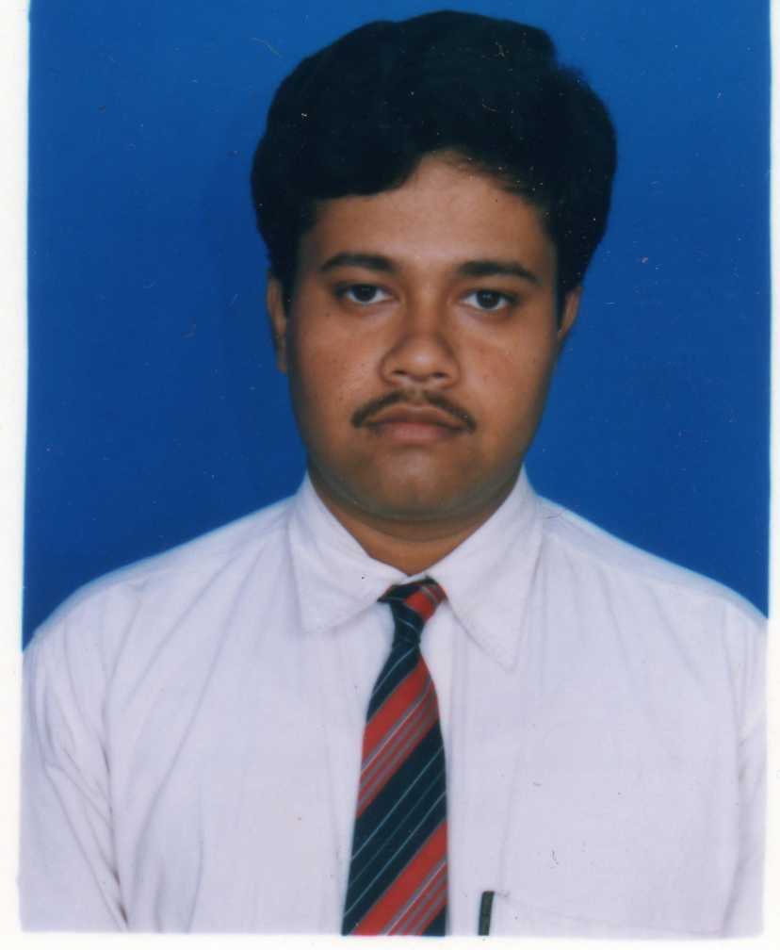
Objective
Put my knowledge to the best use and in line provide a challenging environment to nurture my skills, adding value to the organization and self.
Technical Skills

Languages : C, Core Java, SQL
Web Technologies : HTML, ASP, ASP.NET
GUI : Visual Basic 6.0, C#.NET
Familiar Operating Systems : Windows (98, 2k, XP), Linux (Red Hat 9, FedoraCore4)
Educational DETAILS:

- Master of Computer Application - 2007
Department of Computer Science (University of Burdwan), Burdwan
81.12% .

- Bachelor of Computer Application - 2004
Michale Madhusudan Memorial College (University of Burdwan), Durgapur
66%

- West Bengal Higher Secondary Examination - 2001
Bidhan Chandra Institution (WBCHSE), Durgapur
54%

- Madhyamik Examination – 1999
Bidhannagar Govt. Spon. Boys’ High School (WBBSE), Durgapur
66.25%
WORK EXPERIENCE:

- Block Informatics Officer, Jamuria Development Block,Goverment of West Bengal (Apr 2007-present): I am monitoring the entire computer related work in the Block Office.
ProJECTS EXPERIENCE:

- Voice Communication for Central Mechanical Engineering Research Institute, Durgapur : (Under supervision of Dr.S.Majumder, Surface Robotics Group Head, CMERI)(Duration: 5 months)
Description: The project aims at making voice call over the Intranet using Internet Protocol (IP) address.
Tools and Languages Used: Core Java, Java Media Framework, Java Swing and Eclipse (IDE) on Windows 2000 Professional platform.
P.T.O.
- Payroll System for Central Bank of India, Durgapur: -

Description: The projects aims at keeping a record of all the employees of Central Bank of India Durgapur (according to their posts), their attendance and hence calculate their salaries, considering all the leaves taken (Casual Leaves, Medical Leaves, etc) and the holidays for the particular month. It thus generates their pay slips. The security aspects were well kept in mind while preparing the project.
My role in the project was to do the coding part along with three other members who were also involved in the project.

Tools Used: - Visual Basic 6.0, Oracle 8, Crystal Reports on Windows 98 platform.

- Library Information System for Michael Madhusudan Memorial College, Durgapur: -

Description: The system is used to collect, manage and display all information regarding library of the college.
My role in the project was to do the coding part.

Tools Used: - Visual Basic 6.0, Oracle 8, Crystal Reports on Windows 98 platform.

- Online Shopping System: -

Description: It is internet based 3-tire system. This system has three types of user customer, seller and supplier. In this system customer search for a product and place order from client machine which is any where in the world. Seller can maintain the inventory and monetary transaction. Seller can place order to the supplier. Supplier supplies the product to the seller.

My role in the project was to do the design and coding part.

Tools Used: - ASP.NET, Oracle 8i and HTML.

PERSONAL DETAILS:

Father’s Name : Basudeb Mitra
Mother’s Name : Maya Mitra
Date of Birth : 20.04.1983
Sex : Male
Caste : General
Languages Known : English, Bengali and Hindi

DATE: (sourav Mitra)

