RESUME
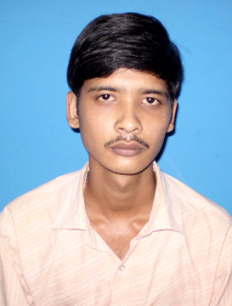
KOUSIK MAITY
S/O Ranajit Maity
Vill - Sital pur,
P.O+P.S-Shyampur
Dist - Howrah.
Pin – 711314 (West Bengal)

Job Objectives:

Looking forward for a challenging position in the professional organization where I can enhance my skills and strengths in tune with the company’s goals and objectives.

Personal Details:

Date of Birth : 21St December 1982

Personal Address : Vill - Sitalpur,
P.O. - Shyampur,
P.S. - Shyampur,
Dist -Howrah,
Pin -711 314 (West Bengal.).

Present Address : C/o- Bisawjit Maity
Ganganagar 1no Coloni,
p.o- Ganganagar,
P.s- Air-port ,
Dist – North 24 Pargana,
Pin – 700132. (West Bengal.)

Contact no. : +919836662743 / 9434515204

E-mail id : kousik.maity.123@gmail.com

Educational Background:

Passed B.A.(Hons)from University of Calcutta,2003.
Passed Higher Secondary from W.B.C.H.S.E in 2000 Arts.
Passed Secondary from W.B.B.S.E in1998.

Technical Qualification: Diploma in Photography from the Institute of Anandaniketan in Ghoraghata.

Computer Basic& D.T.P., course from The Institute of Lalani Computer Academy in Shyampur,

1. Basic [Dos, Windows, Ms-Office (Word, Excel, Access, Power Point and Internet & Outlook express) ],

2. DTP [Photo shop, Corel Draw, Page Maker, Bengali Software, Free Hand etc.],

Practical Knowledge: Adobe premiere, After Effects, Illusion, Flash-Mx, Dream-weaver etc.

Extra: Software-instillation Windows, Windows-Xp, Application Software, Assembling-Pc.

Experience : a) Work in TATA Distributorship as an officially data entry put up in the
Computer & Recover Customer Problem in phone.

b) Working in a faculty at the Diganta computer Academy (
Gujarpur, Shyampur, Howrah),

c) Managements working in a Cyber Cafe and Video camera mixing.

d) Text-Style Designing in a Riya Art Center.

Language Known: Bengali (read, speak& write)
English (read, write& speak)
Hindi (speak)

Interest Area: Poem Write, Reading Story , Watching T.V., known about markets new
company.

