RESUME

ARIJIT ODDAR 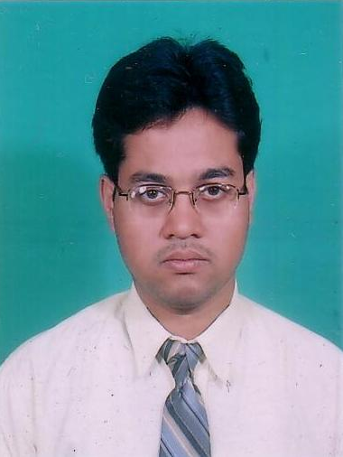

CAREER OBJECTIVE:

Looking for challenging and professional sphere where I could enhance and pursue my skills, which would provide me with opportunities for continuous career growth and development.

ACADEMIC QUALIFICATION:

Educations:
- Pursuing PGDM (Marketing) Final year under All India Management Association (AIMA).
- In 2006 passed B.Sc. (Computer Sc, Mathematics & Physics) under Calcutta University with 48.45% (2nd division).
- In 2003 passed Higher Secondary Examination under W.B.C.H.S.E. with 66.4% (1st division).
- In 2001 passed Secondary Examination under W.B.B.S.E. with 64.85% (1st division).

Computer skills (Technical Knowledge):
- “Basic &MS office, SQL+(Oracle), FORTRAN ” from college as computer sc. was one of my subjects.
- “Certificate course in C, C++ & C# ” from CMC Ltd.
Extra curricular activities:
Taken part in local First-aid Camp and Blood Donation Camp.

PERSONAL DETAIL:

Date of birth: 15th November 1984.
Language Proficiency: English, Bengali and Hindi.
Hobbies: Dealing with different types of Software, Reading books & playing chess.

CONTACT DETAIL:

Postal Address:
Budge Budge, Uttar Shyampur, Paruipara.
Kolkata-700137.West Bengal. India.
Mobile number: +919831072399.
E-mail: arijit_oddar123@yahoo.co.in.

REFERENCES:

Available from,
Academy for professional excellence (apex).
2/1C Townshend Road, Bhowanipore, kolkata-700025.
Ph. No.: 033-24744505/4506/4152.
E-mail: info@apexindia.org.
Website: www.apexindia.org.

Place: Kolkata. Arijit Oddar.

Date: 22/05/2008

