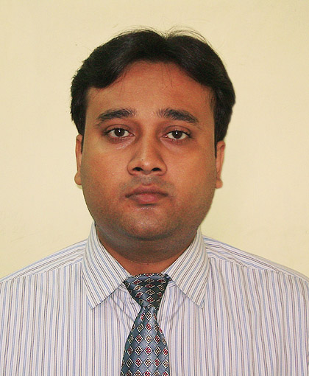

ANISH MUKHERJEE
60/16, Mahendra Banerjee Road,
Ramkrishna Pally, Behala,

Kolkata – 700 060
 9748351699  anishmukherg@yahoo.com

OBJECTIVE :-
To serve any company with my ability to provide excellent customer
care services so that they revert to the company again and again for the services.

EDUCATIONAL QUALIFICATION :-
- Passed Madhyamik Examination from West Bengal Board of Secondary Education in the year 1999
- Passed Higher Secondary Examination (10+2) from West Bengal Council of Higher Secondary Education in the year 2001
- Doing B.A. (Hons.) in Sociology from Netaji Subhash Open University as correspondence course
PROFESSIONAL QUALIFICATION:-
- Dual diploma in Travel Tourism & Hospitality Management with globally recognized certification.
- Appeared dual diploma in Travel Tourism & Hotel Management 2007. IATA \ UFTAA Foundation Diploma Course with CRS (GALILEO) all from M.P.T.I. (India) an ISO 9001 2000 certified Institute ATC-IATA-UFTA.

Professional Experience : -
- Practical & Professional exposure : during my course I have done various model practical works get different professional exposures.
- Passenger handling procedure
- Preparation of itineraries
- Travel arrangement reservation
- Construction of International fares
- Documentation (passport and visa formalities)
- Tour guiding and escorting
- Issuance of ticket manual
- Front office
- House keeping
- Hotel maintenance
- Food & Beverage services
- Different official corresponding
WORK EXPERIENCE :-
- Worked as Helpdesk Executive at Saptak Infotech
2. Worked with Disha Travels
3. Working as Front Office & Travel Desk Executive at Puri Hotel Pvt. Ltd. since May 2008
OTHER SKILLS :-
 Basic knowledge of computer (Windows Office, Power Point, Internet), Photoshop, Freehand, Hardware.

PARTICIPATION : -
- Actively participated in different travel and tourism projects
- Exposition promotional activities

DESTINATION EXPOSURE : -
- Actively participated in all educational excursions
- Destination Rajasthan, Himachal Pradesh and various other places.

DATE OF BIRTH : 20th January, 1981

FATHER’S NAME : Sri Anup Kumar Mukherjee

PERMANENT ADDRESS : 60/16, Mahendra Banerjee Road,
Ramkrishna Pally, Behala,
Kolkata – 700 060

CONTACT NO. : 033 2445 9914 (R)
09748351699 (M)

MARITAL STATUS : Single

SEX : Male

NATIONALITY : Indian

LANGUAGES KNOWN : English, Bengali, Hindi, Nepali, Oriya,
French (learning)
HOBBIES & INTERESTS : Traveling, Socialising, Swimming and Fishing

