CHANDRANI SANYAL

Address – P.O. & Vill- Fingapara, Kankinara
Dist-24 parganas (N) Contact No. – 9830913023
West Bengal (033) 25814544
Pin-743129
E-mail – chandrani2007@gmail.com
chandrani_sanyal@yahoo.co.in

Objective : Intend to work with a leading organization where I can fully utilize
as well as improve my technical and human skills.

Academic Qualifications :

Degree &  Diploma | Board /University | Institute | Year of Passing | Percentage of  Marks
M.C.A. | West Bengal University of Technology. | RCC Institute of Information Technology | 2008 | DGPA: 8.14  81.4%
Diploma in Software Engineering |  | NIIT | 2005 | 71.8%
B.Sc(Physics) | University of Calcutta | Bangabasi  College | 2004 | Total: 54.5%  Hons: 50.9 %
Higher Secondary | W.B. Council of Higher Secondary Education | Rathtala  Rajlakshmi  Balika  Vidyamandir | 2000 | 69.6%
Madhyamik | W.B. Board Of Secondary Education | Rathtala  Rajlakshmi  Balika  Vidyamandir | 1998 | 84.5%

Working Experience :

Name of the Company | Am Soft
Position | Web Developer
Work Experience | 10 months
Area | PHP,MySQL

Skill Synopsis : • PHP, C, C++, Java, JSP
• RDBMS (Oracle), MySQL

PROJECT :1 (From:-February 2008 to May 2008)

Project Name | Online Student Admission System for Post Graduate Courses
Project Location | Bengal Engineering and Science University - Shibpur
Details of Skills used | Languages: - JSP, SQL, HTML  Data Base : - My SQL

PROJECT :2 (From: - September 2007 to Dec 2007)

Project Name | Generic Project Management Portal
Project Location | RCCIIT -KOLKATA
Details of Skills used | Languages: - JSP, SQL, HTML  Data Base: - Oracle 8i, 9i.

Personal Details : Date of Birth : 5th March, 1982
Nationality : Indian
Father’s Name : Shri Utpal Kumar Sanyal
Father’s Occupation : Sr. BSNL Executive
Mother’s Name : Smt. Chaina Sanyal
Mother’s Occupation : Housewife

Languages Known : English , Hindi , Bengali .

Other Interests :
1. Music :
Completed 2nd year in Vocal Classical and Tagore Songs.

2. Reading.

I hereby declare that the above written particulars are to the best of my knowledge and belief.
Date : 23.03.2009 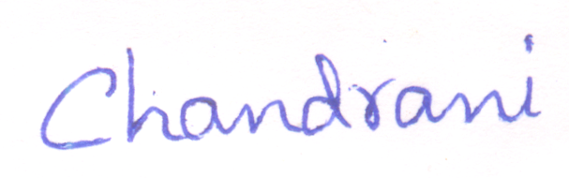
( CHANDRANI SANYAL )

