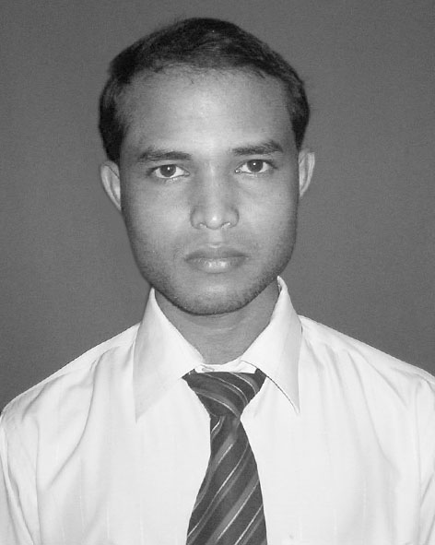
ASHOK MALLICK
ashok_mallick22@rediffmail.com

C/o- Panchanan Mallick
AT- Badambadi GRIDCO Colony QR No 2RA 49
PO-Arundaya Market
Dist-Cuttack
Pin-753012, Ph-9861036966(M), ORISSA

CAREER OBJECTIVE:
To purse as an accomplished technical professional in an Organization to get exposed latest technology synergistically with allegiance and optimize achieving common goal.

PROFESSIONAL QUALIFICATION:
University : BIJU PATTNAIK UNIVERSITY & TECHNOLOGY, ORISSA
- Bachelor Technology in Computer Science & Engineering from Gandhi Institute of Engineering & Technology, Gunupur (2005 - 2008) and Securing 67%.
University : STATE COUNCIL OF TECHNICAL EDUCATION & VOCATIONAL TRAINING, ORISSA
- Diploma in Information Technology Engineering (2000 - 2003) from Sundargarh Engineering School, Sundargarh and Securing 62% of marks.
University : BOARD OF SECONDARY EDUCATION, ORISSA
- HSC (10th) from Badambadi New Colony High School, Cuttack (2000) and securing 66% of marks.

PROFESSIONAL TRAINING :
Duration : 6 Months
- Computer Hardware & Networking Training from Central Tool Room & Training Center Bhubaneswar (An Indo Denmark project from Govt. of India).
Duration : 6 Months
- JAVA Developer Training from 3M Infotech Pvt. Ltd., Bhubaneswar
- Major Subjects : Core Java, Exception, IO, JDBC, Applet, Thread, File Handling Servlet, JSP, J2EE, Struts, AJAX, Java Beans, Tiles and Networking.

TECHNICAL SKILL :
Programming Language : C, C++, JAVA
Scripting Language : JAVA Script, HTML, PHP
Operating System : Windows 98, 2000, ME, XP, NT, NT Server, NT Workstation, RED Hat,
Windows VISTA.
Networking Skill : Creating LAN Infrastructure, Setting Virtual Private Network (VPN), Setting
DHCP, DSN, Firewell connectivity, Router Confrigation, Installation Wi-fi
Network, creating Wireless and Bluetooth Network, Server Computer Confrigation.
Application Software : Photoshop, Pagemaker, Adove Premier, Dreamwaver, Flash, Maya,
Blue Voda, MS Office XP, Akruti, Corel Draw, My eclipse and etc.

EXPERIENCE :
- 2-year experience in Computer Hardware & Networking and Server Management.
- 10 months of project experience in Java Struts, Tiles, Beans and graphic design technology from 3M Info-tech Pvt Ltd.
FINAL YEAR PROJECT WORK :
- Title : ASCE-Web Automation and www.adviatagiet.com
- Technologies Used : PHP,HTML,AJAX,JAVA Scripts
- Design Technology : Photoshop, Flash Maker,
- Database tools : MYSQL
- Role : Managing Database
PROJECT AT A GLANCE :
- The aim of the project was to create an online database management system and developing a web application facility to provide different user. The database considered was the department of computer science of our college. Any authorized member of the department from anywhere can manage the database as it is enabled on a network system. The basic technologies used were APACHE SERVER for server side applications, MY SQL and PHP for database creation and coding respectively.
ACTIVITY :
- Punctual and Hard Working, Aggressive, Friendly, Creative, Analytical Problem Solving, Adaptive, Good team player, Self motivated and leadership quality.

INTERESTS :
- Internet surfing, Reading Books, Designing Web Pages, Solving computer Hardware Problems, Reading Newspapers and Making friends.
PERSONAL INFORMATION :
- Father’s Name : Panchanan Mallick
- Mother’s Name : Arati Mallick
- Date of Birth : 25th May 1984
- Gender : Male
- Marital Status : Unmarried
- Religion : Hindu

DECLARATION :
I do hereby declare that the information stated above information are true to best of my knowledge.

Date : 03/04/2008 Signature of the applicant
Place : Cuttack Ashok Mallick

