Interest for post: Software Developer
Reference:

CURRICULUM VITAE
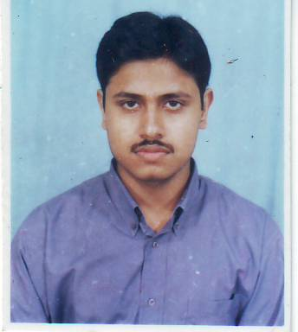  Atish Pyne  Email  atish.pyne@gmail.com  Contact No  Mobile: 9433201244  Present Address  57-C Alipore Road,  Cheatla, Alipore,  Kolkata 700 027  Personal Details  Date of birth : Feb-18-1980  Place of birth: Kolkata  Sex : Male  Nationality : Indian  Marital Status: Single | Summary
 | Seeking a position to utilize my knowledge and abilities in the industry which offers professional growth being resourceful, innovative and flexible, I am ready to work in the field of Software development & operational function in the system of computer.
Experience
Presently working with MCC as a Software Trainee. Having 3 years of experience in DPS Technology Pvt. Ltd., Kolkata as System Supervisor & Data Conversion Operator. Completed training on .NET from Core Network Solution which is of 6 months.
Education

DOEACC A Level in 2006
Assets

- Dynamic analytical and technical skills.
- Effective Communication skill and leadership qualities.
- Highly motivated to work as a team.

Technical Skills

- DBF control in SQL command
- Having RDBMS
- Project designing in VB.Net,VB 6
- C#, ASP.NET, ADO.NET, Crystal Report
- Windows 98, XP
- OCR, Coding & Checking in Data Conversion
Other Details

- CTC: Rs- 5000/ pm
- ECTC: As per industry standard
- Experience in .NET : 1 year
- Total IT Experience: 3 years

Education

DEGREE | COLLEGE/UNIVERSITY | YEAR OF  PASSING | CLASS/  PERCENTAGE*
Doeacc A level | ICEI | 2006 | C (55-64%)
B.Sc.(Pure Science) | Asutosh College  Calcutta University | 2003 | 44.5%
Higher Secondary Examination | Mitra Institution, Bhowanipur Branch, W.B.C.H.S.E | 1999 | 67.5%
Secondary Examination | Mitra Institution, Bhowanipur Branch, W.B.B.S.E. | 1997 | 72.5%

Work Experience

1.Organization Name: DPS Technology Pvt. Ltd. (Kolkata)
Designation: System Supervisor/Operator of Data Conversion
Period: 6th February 2006 to 9th June 2008
Function: | - Responsible for converting the PDF to rtf using all kinds of software which are needed in this process.  - Responsible for using Coding process which is used to convert the rtf to xml and html files.  - Responsible for identification the mistakes that are done at the time of OCR & Coding by the other members of the project.  - Also responsibility for delivery of the job. Before the delivery all kind of projection and presentation done by me.  I have experienced of all four kinds of process that is OCR, Coding, checking and job delivery which are needed for the completion of a project. In the absence of the supervisor I handle the project, and all the people who are in the project.
Client: SPI From PHILIPINES
2.Organization Name: Park InfoTech (Kolkata)
Designation: Trainee Software Programmer (Part-timer)
Period: 14th January, 2008 to 14th June, 2008
Function: | As Software trainee worked for the development of the system of project. The system have used in role over the project procedure. These systems are developed by VB.Net, Sql server and ASP.Net.  The project is developed on Internet Banking System with Sql server and ASP.Net.
3.Organization Name: Management And Computer Consultants (Kolkata)
Designation: Software Trainee
Period: 16th June 2008 - till date
Function: | As Software trainee, is working to develop the system of project. These projects are developed by VB, Unix, Cobol, Sql server and dotNet.  The projects are developed on data handling process with Sql server and VB/VB.Net/ASP.Net.
Client: West Bengal Council of Higher Secondary, Calcutta University

