RESUME

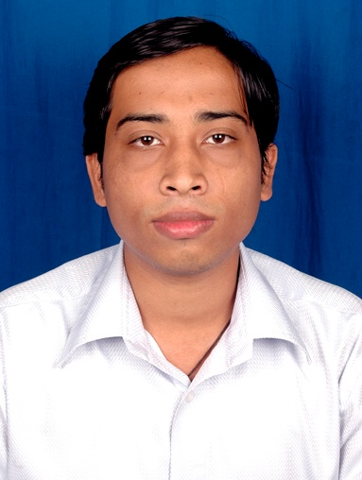
NAME : ABINASH MISHRA

ADDRESS : S/O – A.K.Mishra
12A 2/2 , Balaka Abasan
Newtown, Salt Lake Kolkota-156

E-MAIL : abinashmishra.iitkgp@gmail.com

CONTACT NO. : +919937782127, +919331726350

CAREER OBJECTIVE:
To be placed in a software company and work for a long period of time where I could play a key role in the development of the company

EDUCATIONAL QUALIFICATION:
DEGREE | COLLEGE | UNIVERSITY | STREAM | MARKS/CGPA
Post Graduate Diploma in Information Technology | IIT Kharagpur | IIT Kharagpur | Information Technology | 7.42 (CGPA)
B.Tech | College Of Engineering Bhubneswar | Biju Pattnaik University Of Technology | Information Technology | 7.00(CGPA)
12th | Rourkela Muncipal College | Council Of Higher Secondary Education,Orissa | Science | 40 %
10th | Bajpur high School | Board Of Secondary Education, Orissa |  | 73.33%

EXPERIENCE:
Working as a web developer in Contemporary Equipment & Enterprise Pvt. Ltd. for 3 months.

TRAINING:
VB.NET, ASP.NET from “APTECH” computer education
JSP from LAKSHYA

PROJECT:
Have done projects on
▪ AIRLINE-TOUR PLANNING SYSTEM
▪ SHOPPING-CARD SYSTEM
    - CAR-BUYING-GUIDE

SEMINAR:
- SOFTWARE LIFE CYCLE
- CRYPTOGRAPHY

SOFTWARE SKILLS:
- Front-end : C ,C++ , J2SE ,HTML ,.NET,ASP, PERL
- Backend : ORACLE ,MS SQL SERVER-2000

PERSONAL SKILLS:
- ABILITY TO MOTIVATE PEOPLE
- COMPHRENSIVE PROBLEM SOLVING ABILITIES
- WILLINGNESS TO LEARN
- CAN ADJUST IN DIFFERENT ENVIRONMENTS EASILY
- GOOD VERBAL AND WRITTEN COMMUNICATION

PERSONAL PROFILE:

NAME : ABINASH MISHRA
FATHER'S NAME : AJAY KUMAR MISHRA
SEX : MALE
MARITAL STATUS : SINGLE
NATIONALITY : INDIAN
DATE OF BIRTH : 28TH APRIL 1983
LANGUAGE KNOWN: ORIYA, HINDI , ENGLISH
HOBBIES : Playing Cricket , making friends & watching news and sports

DECLARATION:
I HERE BY DECLARE THAT THE ABOVE MENTIONED INFORMATION IS CORRECT AND I BEAR THE RESPONSIBILITY FOR THE CORRECTNESS OF ABOVE MENTIONED PARTICULARS

DATE:

PLACE: SIGNATURE

