RESUME
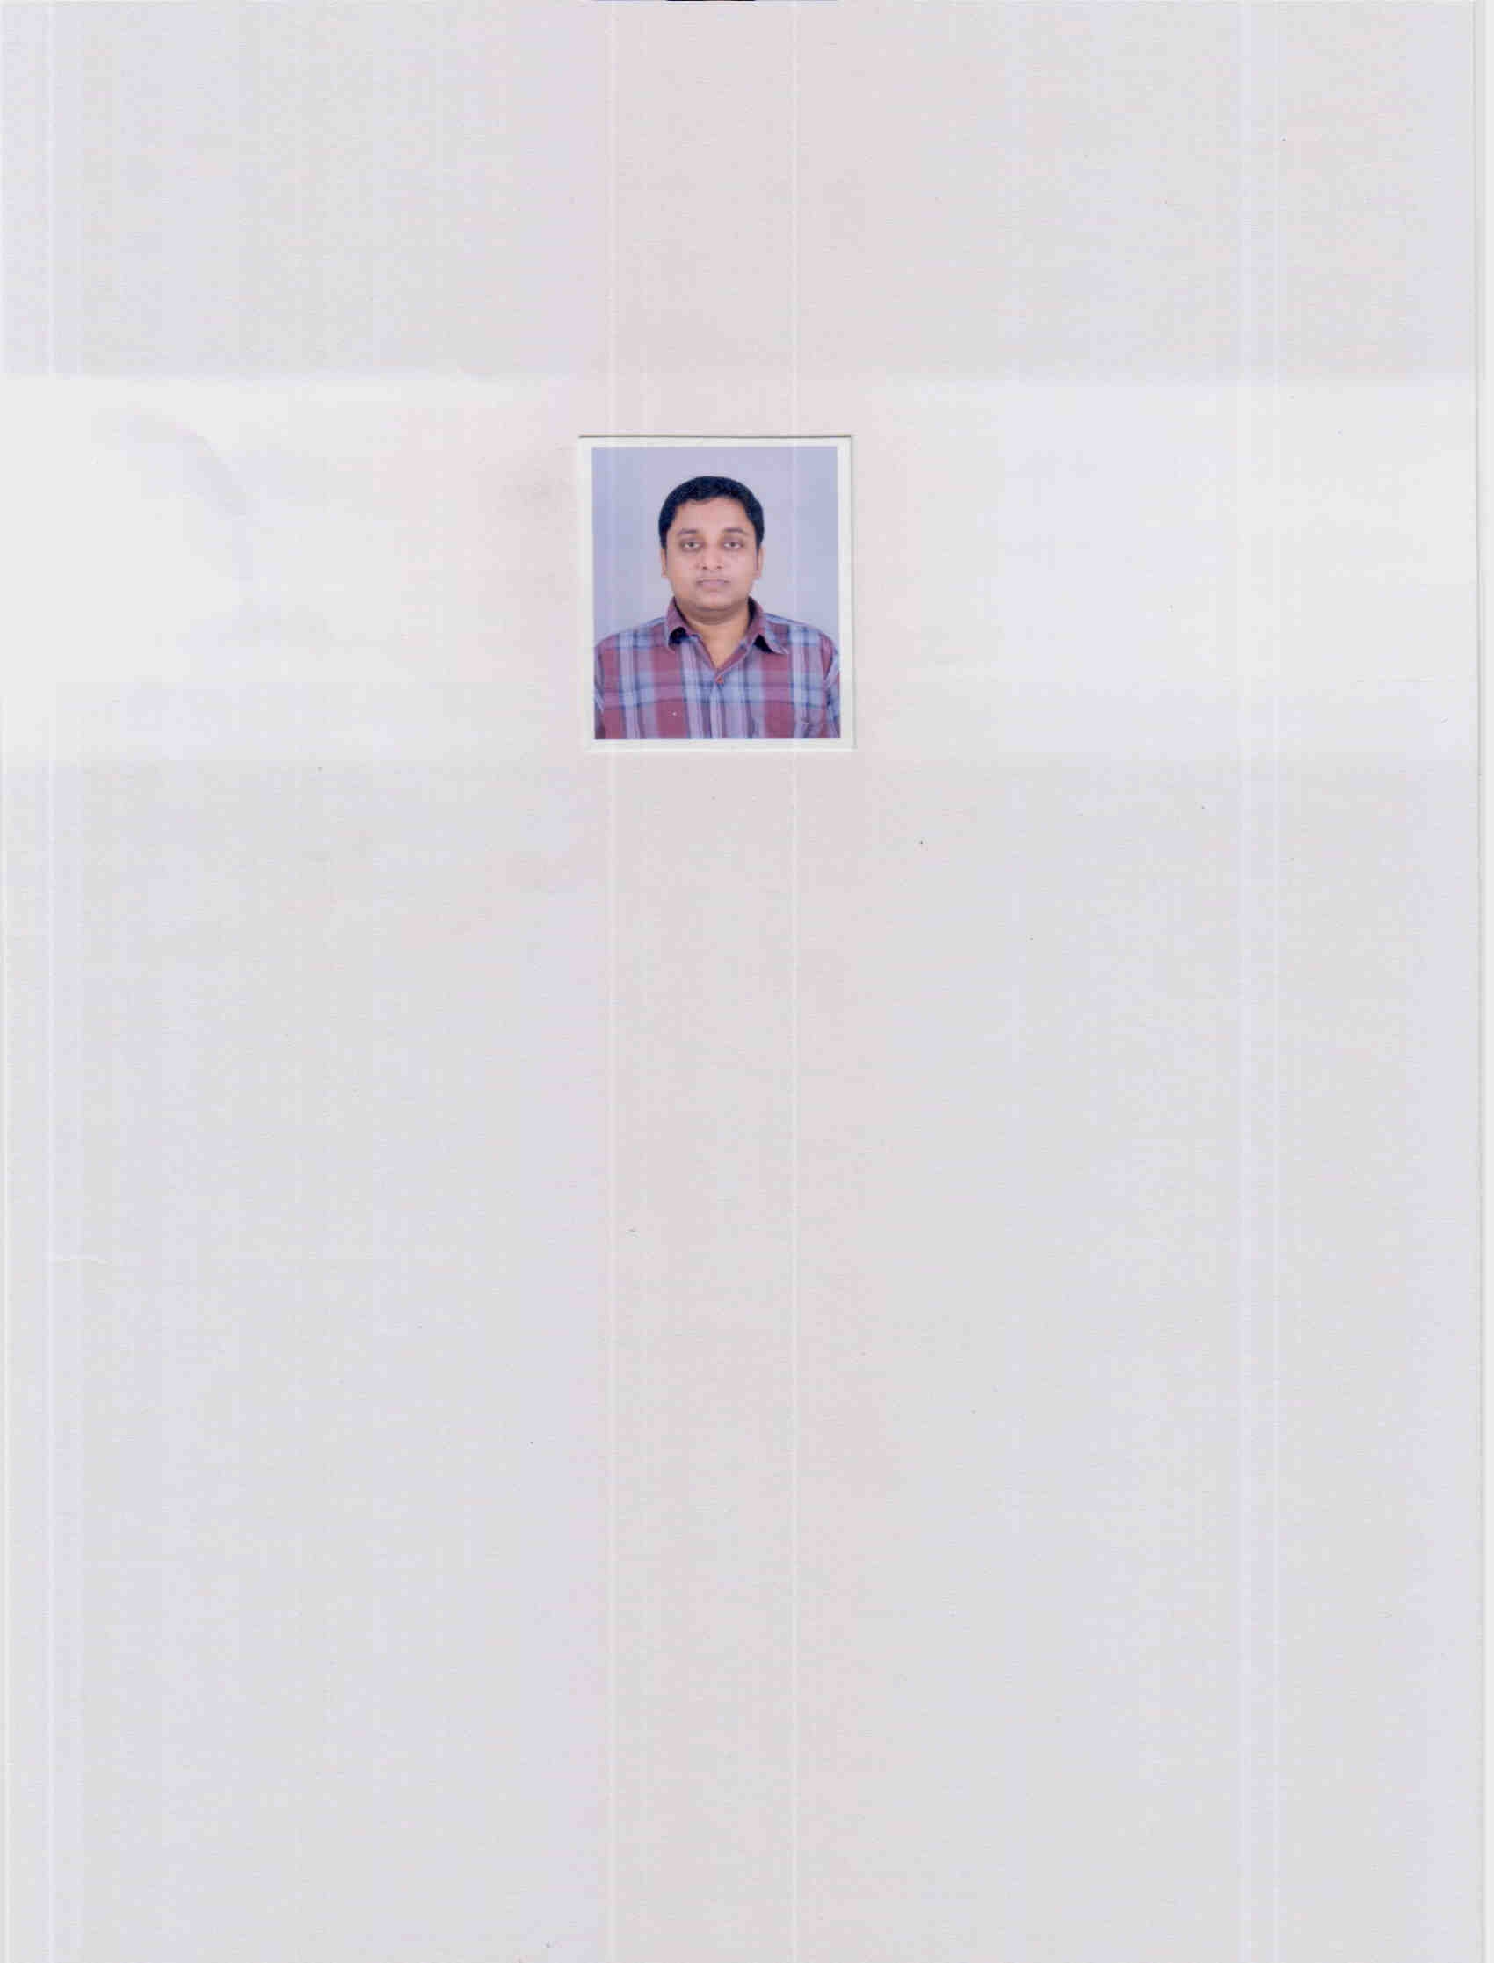
DEBASHIS PURKAIT PHONE NO..- 09903446226
EMAIL- debu123prokis@rediffmail.com

NAME --- DEBASHIS PURKAIT

FATHER’S NAME --- SALIL KUMAR PURKAIT

DATE OF BIRTH --- 30-09-1981

AGE --- 27 YRS

MARITAL STATUS --- UNMARRIED

EDUCATIONAL QUALIFICATION ---

EXAM  PASSED | BOARD/  UNIV. | YEAR OF  PASSING | STREAM | PERCEN-  -TAGE  OF MARKS | DIV.
CLASS-X | CBSE | 1996 | --- | 73% | I st.
CLASS-XII | CBSE | 1998 | SCIENCE | 63% | I st.
B.E. | RGPV  (MADHYA PRADESH) | 2005 | ELECTRONICS  & TELECOMM. | 64.75% | II nd.

EXPERIENCE --- NIL

CONTACT ADDRESS --- C/O- S.K. PURKAIT,
Q.No.- 14-S/FF, RAJABAGAN
ESTATE, ORDNANCE FACTORY,
DUMDUM CANTT., KOLKATA,
W.B.- 700028

SKILL SET -- C/C++ - LANGUAGE, COMPUTER H/W. & N/W.

YOUR CURRENT SALARY : NIL

YOUR EXPECTED SALARY : NIL

NOTICE PERIOD REQUIRED : ASAP

