CURRICULUM VITAE

Communication Address:
C/o Shri U. R. Nayak
Kelovihar, Raigarh (C.G.)
 - 94255-75513
e-mail: – jangade_rama@yahoo.co.in
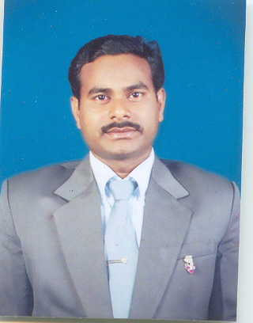

- Personal Information:
Name : Ram Kumar Jangade

Father’s Name : Shri C. R. Jangade

Permanent Address : At/Post – Taparda,
Via – Kondatarai
Distt – Raigarh (C. G.)
Pin – 496 001

Date of Birth : 28th June 1974

Sex : Male

Nationality : Indian

Language Known : English & Hindi

- Qualification:
      - Educational
QUALIFICATION | BOARD / UNIVERSITY | YEAR | MARKS
H.S. Certificate from  S. B.Singh H.S.School Chandrapur (C.G.)  H.S.S. Certificate from  S. B.Singh H.S.School Chandrapur (C.G.)  Bachelor in Science (B.Sc. Maths) from  K. G. Arts & Science College Raigarh(C.G.) | M.P. Education Board Bhopal (M.P.)  M.P. Education Board Bhopal (M.P.)  Guru Ghasidas University Bilaspur (C.G.) | 1991  1994  1997 | 58%  58%  53%

      - Professional

QUALIFICATION | BOARD / UNIVERSITY | YEAR | MARKS
Master of Computer Applications (MCA)  form  Govt. Engineering College Raipur (C.G) | Pt. Ravishankar Shukla  University Raipur (C.G.) | 2000 | 64%

- Computer Proficiency:

1. Operating System : Unix SVR, Windows all versions
MS-DOS 6.22

2. Programming Language : Turbo C, C++, COBOL, PASCAL
Quick Basic
3. RDBMS Packages : MS-Access, MS-SQL, ORACLE9i

4. Application Packages : WS-7.0, MS-Office, Foxpro,
PageMaker 6.5, CorelDraw

5. Hardware Platform : (PC/AT 486), IBM Pentium I, II, III, IV

6. GUI’s : Visual Basic 6.0, VB.NET

7. Internet Tools : Java

8. Web Programming : HTML,DHTML & XML, PHP
VB & Java script

9. Area of Interest : Networking, Software Development

- Others:
N.C.C. : Achievement of National Cadet Corps (N.C.C.) ‘B’ Certificate from K. G.
Arts & Science College, Raigarh (C.G.)
- Experience:
- Approximately five year Teaching & Working experience as a “Programmer” at
Kirodimal Govt. Polytechnic, Raigarh (C.G.)
- At present time I am working as a “Data Manager”, since June 2006 at Office of the Chief Medical & Health Officer, Raigarh (C.G.)

Declaration: I hereby declare all that the information furnished above are true to the best of my knowledge. If any false information has found partially or fully, I would be responsible for guilty.

Date: Signature of Candidate

