CURRICULUM VITAE
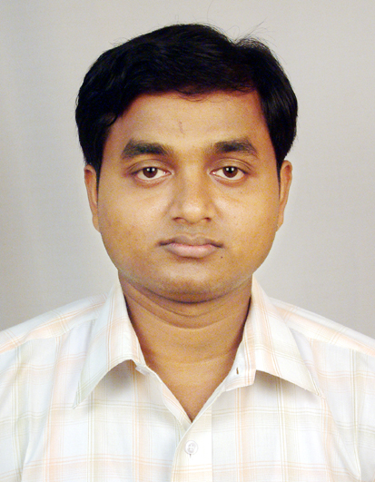

SANDIP MAITY

Address : Madhapur, Hitech City,
Hyderabad.

- Phone No.: 09949302464
- E-mail id : maitysandip.mca@gmail.com

CAREER OBJECTIVE:
Intend to acquire a challenging position in a growing software company that allows me to utilize my potential and creativity.

PROFILE:
- Having 1 Year 3 Months experience in “Software Development”
- Hands on experience in Web Technologies.

WORK EXPERIENCE:
  - Worked as a “Jr. Software Developer (Photogrammetry Section) in Assurgent Technology Solutions Pvt. Ltd.,” from December-2007 to February- 2009.

TECHNICAL EXPERTISE:
- Operating Systems : WindowsXP
- Programming Languages: C, C++, C#3.0.
- Web Technologies : HTML, ASP. Net3.5.
- Scripting Languages : JavaScript.
- Database Applications : SQL SERVER2005

ACADEMIC PROJECT:

Online Course Portal System
(Under Infosys Campus Connect Program)

Duration : 6Months
Team Size: Three
Front end : C#,ASP.NET,Java Script, HTML
Back end : SQL SERVER2000
Platform : WindowsXP

DESCRIPTION:
This project creates a Courses portal for a campus/organization which allows registered users to join a course available in the system.

My Role: To develop the Student, Faculty & Administrator Module.
To design, Coding & Data Base Integration.

EDUCATIONAL QUALIFICATION:

- Completed MCA from Narula Institute of Technology under West Bengal University of Technology in the year 2007 with 8.22(DGPA Out of 10).

- Passed B.Sc.(H) in Computer Science from Panskura Banamali College under Vidyasagar University in the year 2004 with 50.62%.

- Passed Higher Secondary (10+2) from Byabottarhat Adarsha High School under WBCHSE in the year 2000 with 60.80%.

- Passed Secondary (10) from Bhemua Atal Behari High School under WBBSE in the year 1998 with 73.50%.

PERSONAL DETAILS:

Father’s Name : Dinabandhu Maity
Mothers Name : Surama Maity
Date of Birth : 22.10.1983.
Marital Status : Unmarried
Permanent Address : Vill. - Tulia, P.O.-Haridaspur,
P.S.-Tamluk, Dist.-Purba Medinipur, Pin-721636
Gender : Male
Hobbies : Listening Music, Coin Collecting.

I hereby declare that the above-mentioned information is true to the best of my knowledge and belief. I am aware of consequences that might arise if any of the above-furnished information is found to be false or incorrect.

 ______________
Place: Hyderabad [Sandip Maity]

Date: 24.03.09

