CURRICULUM VITAE

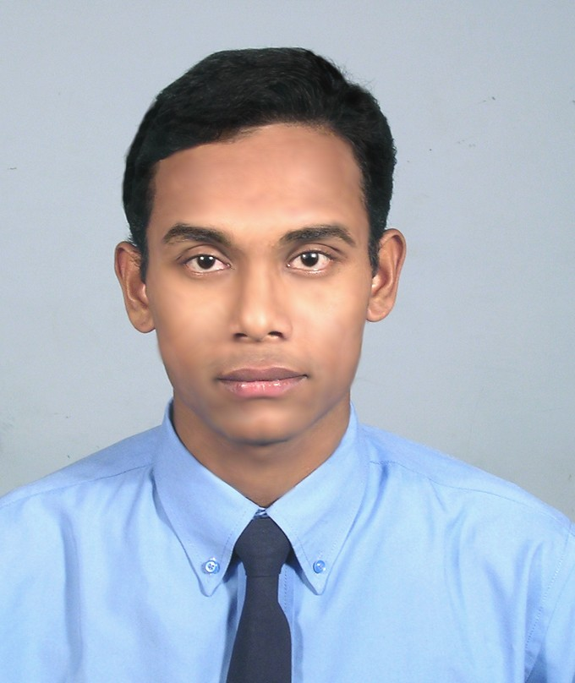

Subasis Patra 15,Sasadhar Tarafder Road
P.O- Sukchar,24pgs (North)
Kolkata: 700115
Mob: 9831296507
E-mail: subasis.pat@gmail.com
subasis_patra5@yahoo.co.in

________________________________________________________________

Career Objective:

To work hard with full strength and talent to achieve the highest possible mark in the life and to be a part of good organizer where I can devote my knowledge and skill for dynamic development of the said organization.

Present Status:

B-Tech Degree in Computer Science & Engineering.

Academic Qualification:

Degree:

University | Course | Institute | Year | Semester | Percentage  ( %)
West Bengal  University of  Technology.  (WBUT).  . | B-Tech  In  Computer Science & Engineering | Bengal Institute of Technology & Management.  (BITM),  Santiniketan | 2003-  2007 | 1st | 76
 |  |  |  | 2nd | 71.3
 |  |  |  | 3rd | 71.3
 |  |  |  | 4th | 74
 |  |  |  | 5th | 79.2
 |  |  |  | 6th | 75.9
 |  |  |  | 7th | 81.9
 |  |  |  | 8th | 89.6

Degree Grade Point Average [DGPA] : 78.3 %

B-Tech. in Computer Science & Engineering from Bengal Institute of Technology & Management, Santiniketan under West Bengal University of Technology, AICTE approved.

Pre-degree:

Examination | Institute | Board/Council | Year | Percentage (%)
ISC (10 + 2) | Little Star High School, Bally. | Council for the Indian school certification examination , New Delhi. | 2003 | 55 %
ICSE (10 ) | St.Xavier’s Institution, Panihati. | Council for the Indian school certification examination , New Delhi. | 2000 | 59.6 %

Project / Traning Summary:

- Participate in summer training organized by XLRI Jamshedpur coordinated by Nettech and awarded “ Certificate in Network Management “ (Linux Environment) held during June-July 2005.

- Certified project on Online Shopping System using platform ASP.NET & SQL Server2000 held during April 2007 from Ardent Collaborations.

Technical Skills :

- Work on Operating System like MSDOS, Windows 98,Window ME, Window 2000,Window XP, Linux.

- Programming languages like C, C++, VB.NET, ASP.NET

- Have knowledge on SQL Server2000.

Extracurricular Activities:

- Net - Surfing and Self learning.
- Playing Cricket, Football.
- Collecting latest Computer Softwares.
- Listening to Music.

Personal Profile:

Name : Subasis Patra

Father’s Name : Salil Kumar Patra

Date of Birth : 5th April 1982

Sex : Male

Blood Group : B negative.

Nationality : Indian

Passport No. : G7468225

Contact Address : 15, Sasadhar Tarafder Road, P.O- Sukchar ,24pgs (North)
Kolkata : 700115, West Bengal.

City : Kolkata

Contact Number : Mob: 9831296507

E-mail : subasis.pat@gmail.com / subasis_patra5@yahoo.co.in

Declaration:

I hereby declare that the above-mentioned information is correct up to my knowledge and I bear the responsibility for the correctness of the above-mentioned particulars.

Date : ______________ ______________________
(Subasis Patra)

