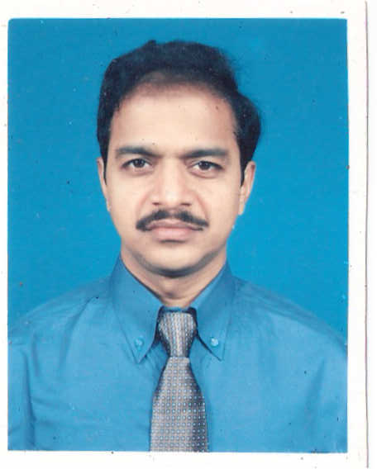

ASHISH KUMAR SHATAPATHY
Contact:+919830590642
email: ashishshatapathy@yahoo.co.in

EXPERIENCE
WORKING AS A TRAINEE PROGRAMMER IN NATIONAL INSTITUTE OF SOFTWARE TECHNOLOGY,
128-A,KANUNGO PARK,
GARIA, TEL: 9339742476 /9339331280/ 24309222.

EMAIL: nist.kolkata@yahoo.com/nist.kolkata@rediffmail.com
Duration: 8months

ACADEMIC CREDENTIALS
2006 MCA from Indira Gandhi National open University(IGNOU), New Delhi.
(Secured 57.22%)
2004 ADCA from Indira Gandhi National open University(IGNOU), New Delhi.
(Secured 58.58%)
2004 BCA from Indira Gandhi National open University(IGNOU), New Delhi.
(Secured 54.86%)
1991 Diploma in Leather Technology from State Council of Technical Education & Training.
(SCTE&T) (secured 61.50%)
1987 12th (10+2 Sc) from Council of Higher Secondary Education(ORISSA).
(Secured 55.60%)
1985 10th from Board of Secondary Education (ORISSA). (Secured 67.50%)

ACADEMIC PROJECT

Summer Project(BCA)
Title: Simulation software in CSMA/CD.
Name of the software : Simulation software in CSMA/CD.
Front End: C++
Duration: 6 Months
ACADEMIC PROJECT

Summer Project(MCA)
Title: Leather Trade on Net.
Name of the software : Leather Trade on Net .
Front End: ASP, HTML
Scripting Language: JavaScript, VB Script.
Back End: Oracle 8i
Duration: 6 Months

PROJECT

Project
Title: Online Banking.
Name of the software: Online Banking.
Organisation Name: NIST, KOLKATA.
Front End: JSP, HTML
Scripting Language: JavaScript
Back End: SQL Server
Duration: 6 Months
IT SKILLS
- Operating System: Windows 98, Windows XP,Linux
- Application: Ms Office
- Language: C, C++, Visual Basic 6.0, Core Java, J2EE
- DBMS/RDBMS: Ms access, Oracle 8i, SQL, SQL Server
- Web Tools: HTML
- Web Application: Jsp

KEY SKILL

- Core Java, JSP

PERSONAL DETAILS

- Date of Birth : 21st April 1970

- Permanent Address : S/O- Chakradhar Satapathy, AT/P.O- ARANDUA, VIA- BASUDEVPUR,
DIST- BHADRAK, PIN-756125 (ORISSA).

- Present Address : C/O-DIBAKAR PANI,29/H/1, LAHIRI PARA LANE, CHATRA,
SERAMPORE, DIST- HOOGHLY, PIN-712204, (W.B.).

- Marital Status : Married.
- Religion : Hinduism.
- Nationality : Indian
- Language Known : English, Bengali, Oriya & Hindi.
- Expected Salary : Negotiable
- Notice Period : At least 15 days

The all above information are valid and true.

Signature_______________________________

Ashish kumar Shatapathy

Date_10/12/08

