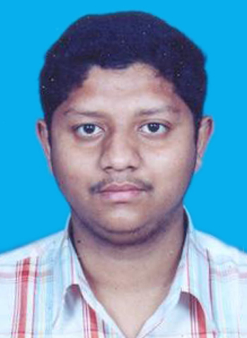

ARKADEV DAS

Contact Address
C/O:Dr. Amitava Das
282, Michael Nagar Road Hand Phone (cell): 9903746843
P.O. Michael Nagar Prefix (0) to avail roaming services
North 24 Parganas Land Phone : +(91)(33)(2)5671896
Kolkata – 700 133 E mail address : arkadev_das@yahoo.co.in

OBJECTIVES
To strive for an excellent designated position in the software industry
and want to fulfill more all less all the tit bits and ethics and strategy
of the core software solutions business industry.
SKILLS
Good communication, presentation, interpersonal and people management skills.
Have got relevant industry oriented or industrial technical and functional skills
in tandem with the business policy of the company and as per industry problem
requirements with time to time .

PROFESSIONAL EXPERIENCES

- Company I S E (P) Ltd ., Salt Lake city, Kolkata , West Bengal
Project Title GEMS
Client Innovative Solutions Experts (P) Ltd .
Team size 5
Environment Oracle E-Business Supply Chain
Designation Supply Chain Consultant (Inv and Purchase modules)
Roles and Responsibilities of this present post
1. Involved in Requirement Analysis and feasibility study.
- Project was implemented using AI methodology.
- Preparing test scripts [TE 020] as per the requirements.
- Developing reports in INV, PO.

Project Objective Application development and maintenance of
Oracle Inventory and purchasing modules .
Client KENEXA , USA
Team size 5
Environment Oracle E - Business Material Distribution
Designation Oracle Supply Chain Consultant
Roles and Responsibilities of this present post
- Worked as a team member and my responsibilities include
requirement analysis , testing and implementation.
- Preparing test scripts .
- Unit and integration testing .Implementation and support of customized modules.

DURATION
7th February , 2007 to till date .

- Company Global Software Solutions (P) Ltd. , New Alipore
ROLE To computerize a sophisticated Human resource management
From an American labour management system depicting book .
RESPONSIBILITIES
Requirement analysis and computerized system
development (Analysis-design – development- testing
and ultimate packaging of the manually described operation system)
DESIGNATION
.Net technology Analyst .
DURATION
July 7, 2006 – October 10 , 2006
613, Block ‘O’, New Alipore, Kolkata – 700 053

- Company Siemens P C N L , SLW , switch assembling factory
Project Title Logistics performance analyzer simulator
(A sophisticated ERP system Package)
Client SIEMENS public communication networks (P) Ltd .
Salt Lake Works , Switch assembling factory,
-- Logistics and Supply Chain Department
Platform Microsoft Windows 2000 Professional
Tools Macro function in Ms office 2000
Designation Programmer Analyst (Logistic & Supply Chain Dept.)
Responsibilities Requirement analysis cum E - System developer
Team Size 4
Duration Aug 10, ‘05 – Mar 30, ‘06 –
April 2,‘06 - June 30 , 2006
Siemens Business Group ; Division: Communications
Department: Logistics: (Previously)
Now Nokia Siemens Networks Limited since June,2006
- Company ARB Software (I) Private Limited
Project Title Online examination system (web based data project)
Client Some unknown foreign client
Platform Microsoft Windows XP professional (A GUI)
Tools Microsoft VB 6, Oracle 9i
Designation Trainee Software Engineer
Responsibilities Design and development of a custom software package
Team Size 5
Duration February – May 2005

- Company MN Dastur & company (P) limited
Project Title Continuous modification of application development process
Client Design and draft engineers of various departments of
MN Dastur & Co (P) Limited , Consulting Engineers
Platform Microsoft Windows XP professional
Tools Microsoft VB 6, Oracle 8i
Designation Programmer Analyst
Responsibilities Programming the present software system
Team Size 4
Duration 6 months contract service : July – December 2004

PERSONAL DETAILS

Date of Birth : 30/05/1982
- Sex : Male
- Religion : Hinduism
- Voter Identity Number : CKW4121745
- Passport Number : G7752770
- Driving Licence Number : WB – 01 – 289809
- Place of Birth : Kolkata, West Bengal
- Father’s Name & Profession : Dr. Amitava Das (Retired Professional)
- Mother’s Name : Late Mrs Kalpana Das

CREDENTIALS
- Oracle Partner Network certified Oracle Distribution consultant.
- Took a 3 months .NET technology training from TOTSOL Private Ltd.
- Got chance in CDAC, Bangalore for the 1 year bridge course of PGDIT .
- Scored 1860 rank in WB – JECA 2003 (MCA entrance exam of West Bengal)

SCHOLASTICS
- Pursued BCA of Kalyani University , WB from B P Poddar Instt.
of Mgmt. & Technology , Kaikhaliin July , 2003 with 76 % marks.
- Pursued ISC (Science) from SAIE , Salt Lake city in 2000 with 70 % marks.
- Pursued ICSE from ST. Stephen’s School , Dum Dum in 1998 with 72 % marks .

Total IT experience 4.6 years
Last drawn salary 2 lakhs / annum
Expected Salary As per the management rules of the company.
Period of Notice 10 days notice from the date of appointment.
Current Location Kolkata , West Bengal

DATE

PLACE ARKADEV DAS

