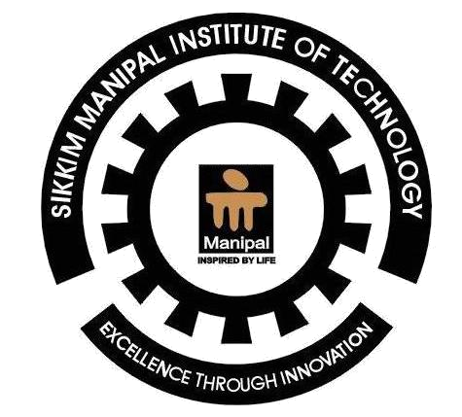
Sikkim Manipal Institute of Technology

(Constituent College of Sikkim Manipal University of Health, Medical and Technological Sciences)

CURRICULUM VITAE
Campus:

SMIT Campus, Majitar, Rangpo East Sikkim - 737132, India
Mobile: + 91-9932734917
Email: satyajit.mohanty83@gmail.com

Permanent:

C/o-sri sudhir ku. Mohanty
QR no.HE-7/2, OSAP 6TH BN campus
Dist-cuttack, 753003(orissa)
Home no. +91-9861115674

Personal Information
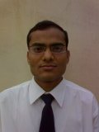

Name: SATYAJIT MOHANTY.

Department : Electronics & Communication

Date of Birth : July 4th 1983

Gender: Male

Nationality: Indian

Objectives: To make best utilization of my knowledge and skills for the progress
Of the company and in process gain valuable experiences.

Summery: • Currently B.tech 8th SEM. In Electronics&communications with GPA-6.76
• Currently doing major project based on “HIGHSPEED DATA COMMUNICATION AND NETWORKING in STPI,BHUBANESHWAR.
•
•

Academic Information
Performance in 10th & +2 level
No. | Course | Board / University | Year of passing | % / Grade
 | 10th | Board of secondary education,orissa | 1998 | 82.13
 | 10+2 | Council of higher secondary education;orissa,bhubaneswar | 2000 | 66.11

Performance in Under Graduate Level (B. Tech./ B. SC.,/ B. Com/ B.A.)
Sem I | Sem II | Sem III | Sem IV | Sem V | Sem VI | Sem VII | Sem VIII
7.02 | 7.00 | 5.912 | 6.54 | 7.14 | 6.14 | 7.61

Projects / Internship undertaken
No. | Project | Organization | Duration | Objectives
1.  2. | Wireline project  Microcontroller based capacitance meter | RelianceCommunications,bhubaneswar  Sikkim manipal institute of technology,sikkim,india. | 1 month  6 month | To make utilization of my project knowledge in industry.

Languages Known
No. | Language | English | Hindi | Oriya

Computer Skills
No. | Languages / packages | Assembly(microprocessor 8085&8086) | C&C++

Extra-curricular activities and hobbies
1. Presented seminar and presentation on “BROADBAND COMMUNICATION AND NETWORKING” in my B.TECH carrier.
2. Participated in Debate and Essay writing competition at school level.
3. HOBBIES: Listening to hindi songs, Travelling.

Additional Information (if any)
ACHIVEMENTS-Awarded by the URBAN CO-OPERATIVE BANK of ORISSA for the 1st position in class 9th(STATE LEVEL).

Declaration
I do hereby declare that all the information given by me are above are correct and if there is any discrepancies are found, I may be disqualified from the selection process of the company.

Place : SMIT, Majitar, Sikkim
Date : 11/09/2008
Signature :satyajit mohanty.

Referrences :
For Projects / Internship / Final placement of this student kindly contact:
Dr. Ashish Sharma
Head – Training & Placements, Sikkim Manipal Institute of Technology
Tel. 03592 – 246220, Extn. 274,Tel. 03592-246217, Fax: 03592 – 246112
Mobile:9434117367,9800236435, E-mail: tnp.smit@gmail.com

