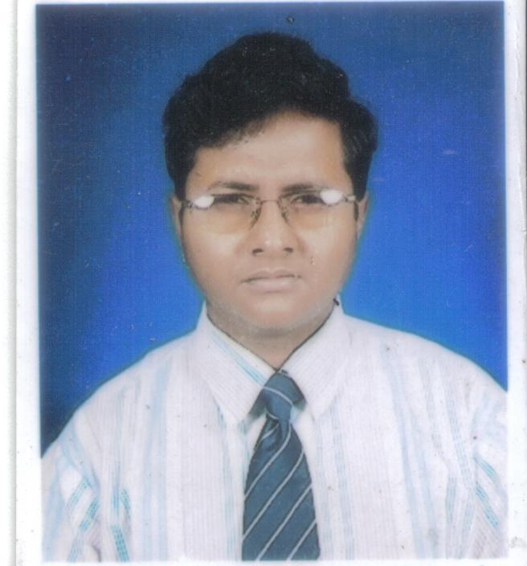
RESUME
Kalyan Roy
Computer Science & Engineering
University Institute of Technology
Burdwan University

Personal Details
Father’s Name : Mr. Karun Roy
Date of Birth : 31 October,1987
Permanent Address : Vill+ P.O. - Dattapulia ;Dist - Nadia ;
Pin - 741504 ; West Bengal.
Nationality : Indian.
Category : General
Mobile No. : 09733711471 / 09477007802
E-mail id : kalyanroy@systsol.com , kalyan_roy23@yahoo.com
Kalyanroy.08.13@gmail.com

Career Objective
Want an opportunity to elaborate my technical skill and analytical ability in the software industry with my sincerity and hard-working.

Academic Qualification

Χ^{th} & ΧΙΙ^{th} Standard
Examination |  | Board/ University |  | Year |  | Institute |  |  | Percentage
Madhyamik  Higher Secondary |  | W.B.B.S.E.  W.B.C.H.S.E. |  | 2003  2005 |  | Duttapulia Union Academy  (H.S)  Duttapulia Union Academy  (H.S) |  |  | 80.00  76.40
B.E. Standard
Semester | Board/ University |  | Institute |  | YEAR |  | SCPA | Average (%)
I  II  III  IV  V  VI  VII  VIII  Average | .  Burdwan  University |  | UIT |  | 05-06  05-06  06-07  06-07  07-08  07-08  08-09  08-09 |  | 61.4  58.4  59.2  77.5  77.9  80.4  74.7  83  TCPA=74.3 | 65.09  63.90  62.14  78.88  78.78  80  76.14  83.29  73.52
SCPA=Semester Credit Point Average; UIT= University Institute of Technology;
TCPA=Total Credit Point Average
Technical Skills
- Languages : C
- Query language : SQL
- Working Platforms : Windows98,XP,Vista,Linux
- Fundamentals : Data Structure ,DBMS , Operating System , Automata

Extra Curricular Activities
- Participated in various Quiz Competitions
- Playing Tablas.

Hobbies
- Listening Music
- Playing Computer games
- Reading Story Books

Declaration
I do hereby declare that all the statements given above are true to the best of my knowledge. … …………..……………………………
Date:30-11-09 (Kalyan Roy)

