RESSUME

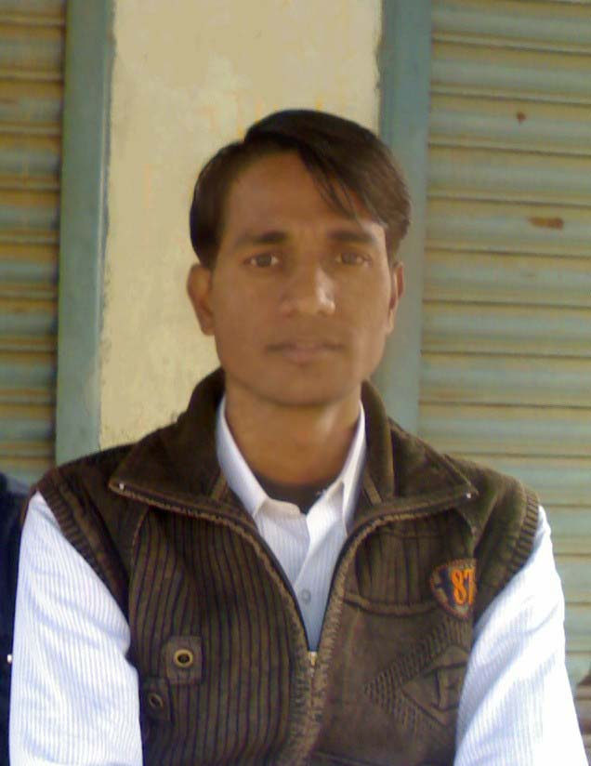
Md.Tanwir Alam

Father’s Name :Md.Muslim

Date of birth :7 March 1988

Residence :Village-Shishiya, P.O-Kant Nagar, Via-Guru Bazar, Dist.-Katihar(Bihar) PIN-854104

Contact No. :+919204760128
Email id- tanwirmit39@gmail.com
Sex :Male

Marital Status :Unmarried

Nationality :Indian

Language Known :Hindi,English, Urdu & Bangla.

Hobbies : Visiting Historical & Religious places.

Whether belongs to ST/SC : No

Academic qualifications :
Degree | Year of  completion | University | Division | Subject
Secondary | 2003 | B.S.E.B., Patna | 1st.Div. | Eng, Math, Phy, Chem, Biology
Intermediate | 2006 | B.I.E.C., Patna | 2nd.Div. | Eng, Phy, Chem, Mathe.
B.Tech | 2010 | B.M.U.  Madhepura | Persuing | Electronics &  Communication Engg.

PLACE: Purnea
DATE : 11/01/2010
Signature:
Md.Tanwir Alam

