KALYAN DAS  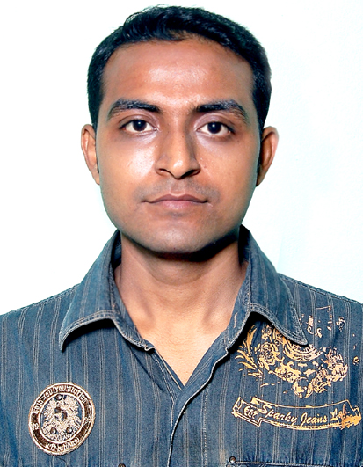  E-mail id : kalyan.dosti@gmail.com | Contact Address :   Vill : Subhas Nagar  P.O : Chakdaha  Dist. : Nadia  Pin :741222,(W.B)   9775036766

Objective

To work in a challenging and highly competitive environment where I would be able to explore my abilities and hence contribute to the best of myself.

Personal Skills

Extremely energetic, self-motivated, committed to excellence, good communication skill, team building capability and can motivate a group of people to achieve a particular goal.

Academic Qualifications

Serial  No. | Examination Name/Degree with Branch | Name of The Board/University | Year of Passing | Division
1. | Madhyamik Pariksha (10) | W.B.B.S.E. | 2002 | 2nd
2. | Higher Secondary (10+2) | W.B.C.H.S.E | 2004 | P
3. | B.com | Kalyani University | 2007 | P

Technical Proficiency

Operating Systems | MS Windows XP, Windows 2000, Windows98, MS-DOS,
Language Proficiency | MS-WORD, MS-EXCEL,
Special Language proficiency | Tally 9.0 (Release 1.3)

WORKING EXPERIENCE

Name Of Organization | Period | Nature of Working
M/S. Monju Traders | 18 months | Working as a Computer Assistant  (M.I.S & D.S.R of Reliance Comm)

Other Personal Information

Date of Birth | 23rd May 1984,
Nationality | Indian
Sex | Male
Marital status | Single
Guardian | Kushal Chandra das
Languages Known | Bengali, Hindi, English,
Hobbies | Discussions among friends, Reading story books, Listening & singing songs. Playing several games. Adventure.

About Myself

I think determination, dedication, and hard work can help to achieve one's desired goals in life. I also can organize a program confidently with others even under pressure. I can be a team leader if responsibility is entrusted to me. My outlook towards the various struggles and hardships in life is: Dedication and hard work does pay. Just work hard towards your goal and don't bother about the failures that may arise for it has been rightly said that failure is the pillar of success. The valuable keywords that inspire me to go ahead with my allotted task are the three D’s, which are “Determination, Dedication and Diligence”.

Date: ……………………………………
Place: Chakdaha Signature
(Kalyan das)

