College of Engineering and Management, Kolaghat(C.E.M.K)
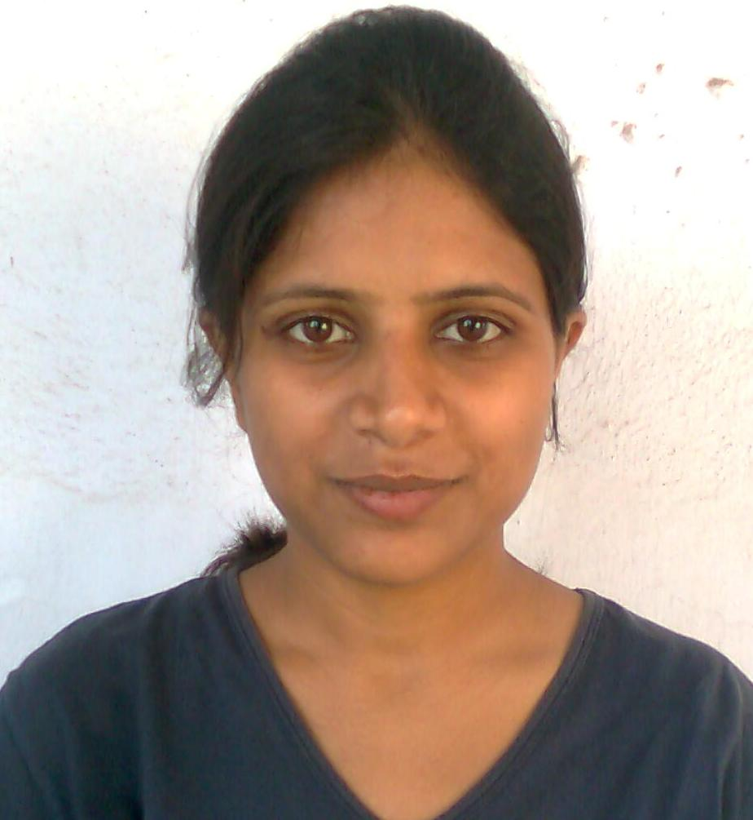x one Recent PassportSize Photograph here
(Sc an for softcopy)
Affiliated to West Bengal University of Technology(W.B.U.T)
Government of West Bengal.

♦ OBJECTIVE

To build a career that stimulates the mind, cultivates work ethic and allows to confront fresh challenges and scale newer heights & to secure a challenging position where I can effectively contribute my skills as a Technical professional, by continuous learning.

♦ Academics

♦ Institution : JANTA HIGH SCHOOL (X)
ADARSH VIDYA MANDIR(A.V.M) (XII)

♦ Board : JHARKHAND SECONDARY EDUCATION BOARD(X)
CENTRAL BOARD OF SECONDARY EDUCATION (XII)

Examination | Year | Marks | Percentage
JSEB | 2002 | 424 | 70%
CBSE | 2004 | 381 | 76%

NOTE: 2 years of gap between academic career is due to taking preparation for IIT JEE & was suffering from Typhoid.

4 Years B. Tech. [Information Technology] Degree Course Results:

Year | Odd Semester Marks  (In Grades) | Even Semester Marks  (In Grades)
I | 7.87 | 8.03
II | 7.93 | 8.41
III | 8.54 | 8.25
IV

- AVERAGE SGPA : 8.27

♦ COMPUTER SKILLS

• O/S |  | : | Windows , Linux
• Language | : C, CORE JAVA, HTML
• RDBMS | : Oracle, MS Access

♦ Subject

♦ Operating system

♦ Project Undertaken
♦ Have done a project on Online Mobile Billing based on ASP.Net from
HCL Infosystem Ltd. Kolkata

♦ e-Governance for Municipality based on PHP, mainly with database
driven by MySql under the guidance of Mr. Sushovan Das,
Department of CSE and IT,College Of Engineering and
Management, Kolaghat, East Midnapur, West Bengal.
Status- On Progress.

♦ PERSONAL DETAILS

♦ D/O : Shri. Mahadeo Prasad Gupta
♦ Address : Teacher’s Colony,Chas-827013
Near kadiya Bhawan
Bokaro Steel City,Jharkhand
♦ Phone : 09933477454
♦ E-mail : bharticemk@yahoo.com
♦ Date of Birth : 12TH MARCH,1987
♦ Nationality : INDIAN
♦ Caste : GENERAL

♦ EXTRA CURRICULAR ACTIVITIES

♦ Participation in cultural programme.

♦ SOCIAL ACTIVITIES

♦ Teaching & motivating children of village during my vacation in hometown.

♦ ACHIEVEMENTS

♦ Awarded by the Science & Technology Minister of Jharkhand for best result
in the School in Jharkhand Secondary Examination-2002.

♦ Hobby
Listening to Music,Cooking,Singing.

Language Known: English (R\W\S),Hindi (R\W\S),Bengali(S).

I here by declare that all the above information is true to the best of my knowledge.

Date: 05th January,2010 Signature:______________
Place: East Mednipur (RICHA BHARTI)

