BIO-DATA
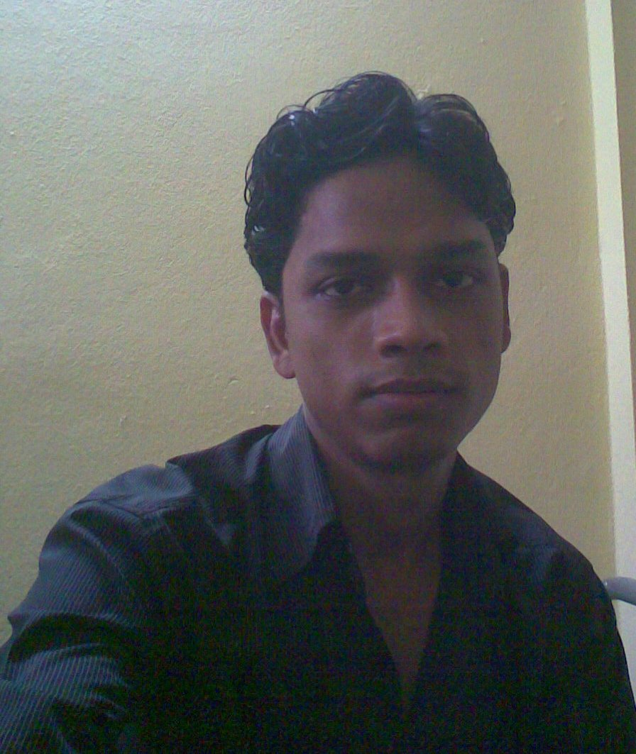
Affix one Recent Passport Size Photograph here
(Scan for softcopy)
Name (in full & in block letters) | : | SUNIL KUMAR
Department | : | INFORMATION TECHNOLOGY
College Roll No. | : | IT/06/A/57

Father's Name |  | : | Late Suresh Prasad
Residential Address |  | : | Sunil Kumar  c/o Rajendra Prasad  Manpur Pehani  P.O BuniyadGanj  Gaya-823003  Bihar
Telephone No. (Preferably Mobile) |  | : | 09933738632
E-mail Address (Only one) |  | : | Sunny23104@yahoo.co.in
Date of Birth |  | : | 23rd October,1984
Caste |  | : | OBC
Educational Qualification |  | :
Examination, Board | School / College, Place |  |  |  | Year of Passing | Total Marks obtained |  | Percentage
10th CBSE | Gyan Bharti ,Bodhgaya,Gaya,Bihar |  |  |  | 2000 | 344 |  | 68.8%
12th CBSE | Gyan Bharti ,Bodhgaya,Gaya,Bihar |  |  |  | 2002 | 336 |  | 67.2%
Diploma Marks
A.I.E.E.E. Rank | 69251 2006
B.Tech.( Department) | Semesters |  |  | Year of Passing |  | SGPA | Average B.Tech SGPA (Till Date)
B.Tech.( Department) | 1st |  |  | 2007 |  | 7.7 | 7.58
B.Tech.( Department) | 2nd |  |  | 2007 |  | 8.26
B.Tech.( Department) | 3rd |  |  | 2008 |  | 6.87
B.Tech.( Department) | 4th |  |  | 2008 |  | 7.37
B.Tech.( Department) | 5th |  |  | 2009 |  | 7.62
B.Tech.( Department) | 6th |  |  | 2009 |  | 7.67
B.Tech.( Department) | 7th
B.Tech.( Department) | 8th

Computer Proficiency:
Language | : | C, CORE JAVA, J2EE, HTML
RDBMS | : | ORACLE, My SQL, MS ACCESS
Operating Systems | : | LINUX,WINDOWS 2000/XP2/ VISTA

Additional Classes Attended: (e.g. JAVA Class /Soft Skill Trg. / Rational Rose etc.) Give Details.
- 1 month Summer Training on J2EE in HCL Career Development Center, HCL Infosystem Ltd., Kolkata

Project Undertaken: Final year project – Image Processing

Extra-Curricular Activities:

Hobbies: listening to music and watching movies

Date: 03-09-09 | Signature: (not necessary for soft copy)

(If necessary, make in two pages)

