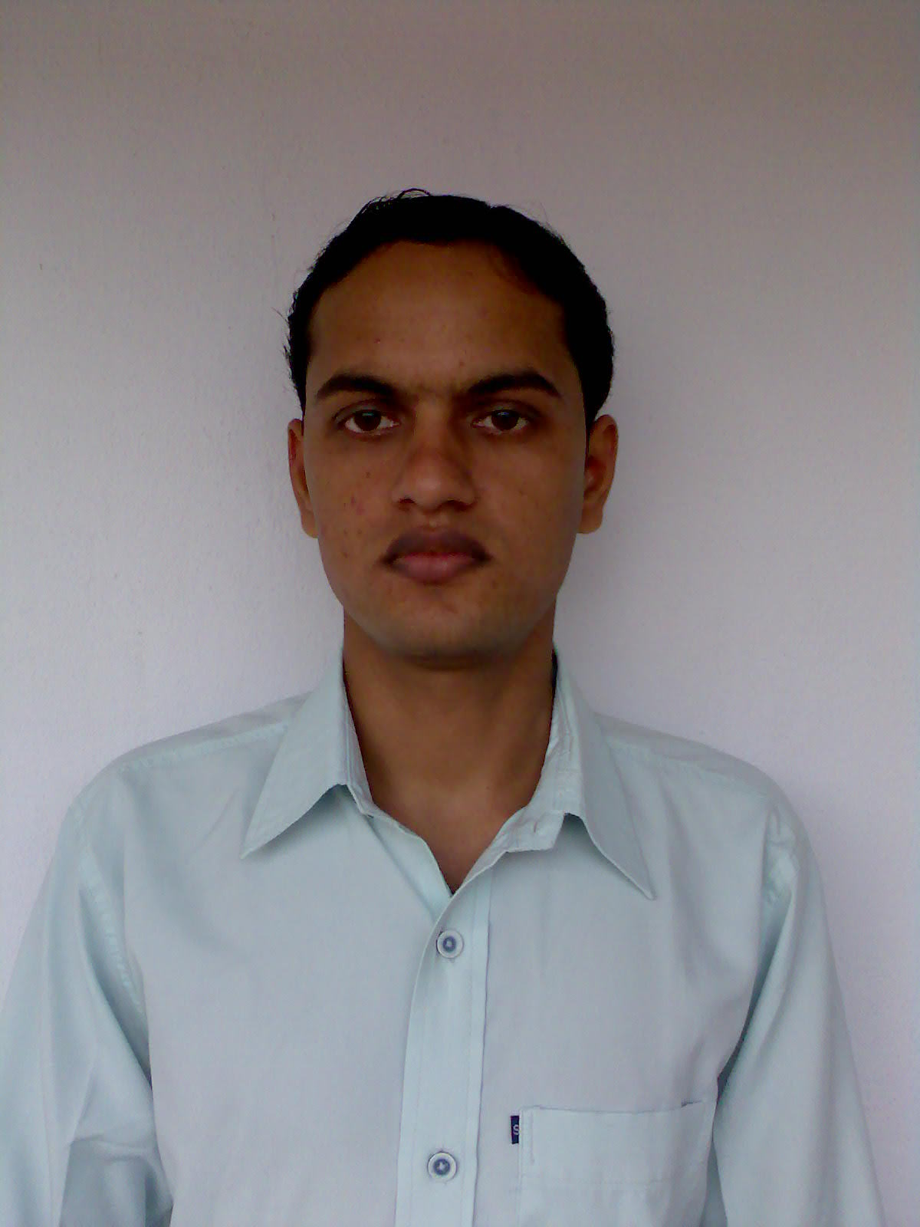
Affix one Recent Passport Size Photograph here
(Scan for softcopy)
Name | : | ARUNJAY KUMAR
Department | : | INFORMATION TECHNOLOGY
College Roll No. | : | IT/06/J/09

Father's Name |  | : | SRI ANIL KUMAR
Residential Address |  | : | C/O:SRI CHANDRASHEKHRA SHARMA SRIKRISHNANAGAR(AURANGABAD)  (BIHAR)  PIN:824101
Mobile No. |  | : | 09933590405
E-mail Address |  | : | arunjaycemk@gmail.com
Date of Birth |  | : | 31/12/1987
Category |  | : | GENERAL
Educational Qualification |  | :
Examination, Board | School / College, Place |  |  |  | Year of Passing |  | Total Marks obtained |  | Percentage
MATRIC,  BSEB, PATNA | ANUGRAH INTER COLLEGE,  AURANGABAD |  |  |  | 2002 |  | 514 |  | 73.43%
INTERMEDIATE,  BIEC, PATNA | S.N SINHA COLLEGE,  AURANGABAD |  |  |  | 2004 |  | 559 |  | 62.11%
J.E.E. Rank | 9436
B.TECH  (INFORMATION TECHNOLOGY) | Semesters |  |  | Year of Passing |  | SGPA |  | Average B.Tech SGPA (Till Date)
B.TECH  (INFORMATION TECHNOLOGY) | 1st |  |  | 2006 |  | 7.83 |  | 7.7
B.TECH  (INFORMATION TECHNOLOGY) | 2nd |  |  | 2007 |  | 8.26
B.TECH  (INFORMATION TECHNOLOGY) | 3rd |  |  | 2007 |  | 6.87
B.TECH  (INFORMATION TECHNOLOGY) | 4th |  |  | 2008 |  | 7.97
B.TECH  (INFORMATION TECHNOLOGY) | 5th |  |  | 2008 |  | 7.58
B.TECH  (INFORMATION TECHNOLOGY) | 6th |  |  | 2009 |  | 7.7
B.TECH  (INFORMATION TECHNOLOGY) | 7th
B.TECH  (INFORMATION TECHNOLOGY) | 8th

Computer Proficiency:
Programming Languages |  | C,JAVA
Web Technologies |  | HTML, XML, JSP, SERVLETS, JDBC, JAVA SCRIPT
Operating systems |  | WINDOWS,UNIX(DEBIAN,LINUX)
Database |  | SQL,ORACLE, PL/SQL
Tools & Packages |  | Net Beans, MS Office
Concepts |  | Data Structure, Operating System, Digital Electronics, DBMS

Additional Classes Attended:
- summer training course on core java in IBM(MCAPL) from 28-06-2008 to 01-09-2008.
- summer training course on J2EE in HP from 29-06-2009 to 29-07-2009.

Project Undertaken:
- Telephone_Directory system based on J2EE.
(Group of 4 members)
- Image processing(under progress) undertaken in C.E.M.K
(Group of 3 members)
- online polling system(under progress) under IBM,TGMC contest.
(Group of 3 members)

Extra-Curricular Activities:
- NCC cadet.
- participated in quiz contest.
- Active member of technical fest “RESONANCE 2008” & cultural fest “SPANDAN 2009” .

Hobbies:
collecting softwares, watching & playting cricket match, swimming

I affirm that the above information is true to the best of my knowledge.

Date:04-09-2009 | Signature:

