BIO-DATA
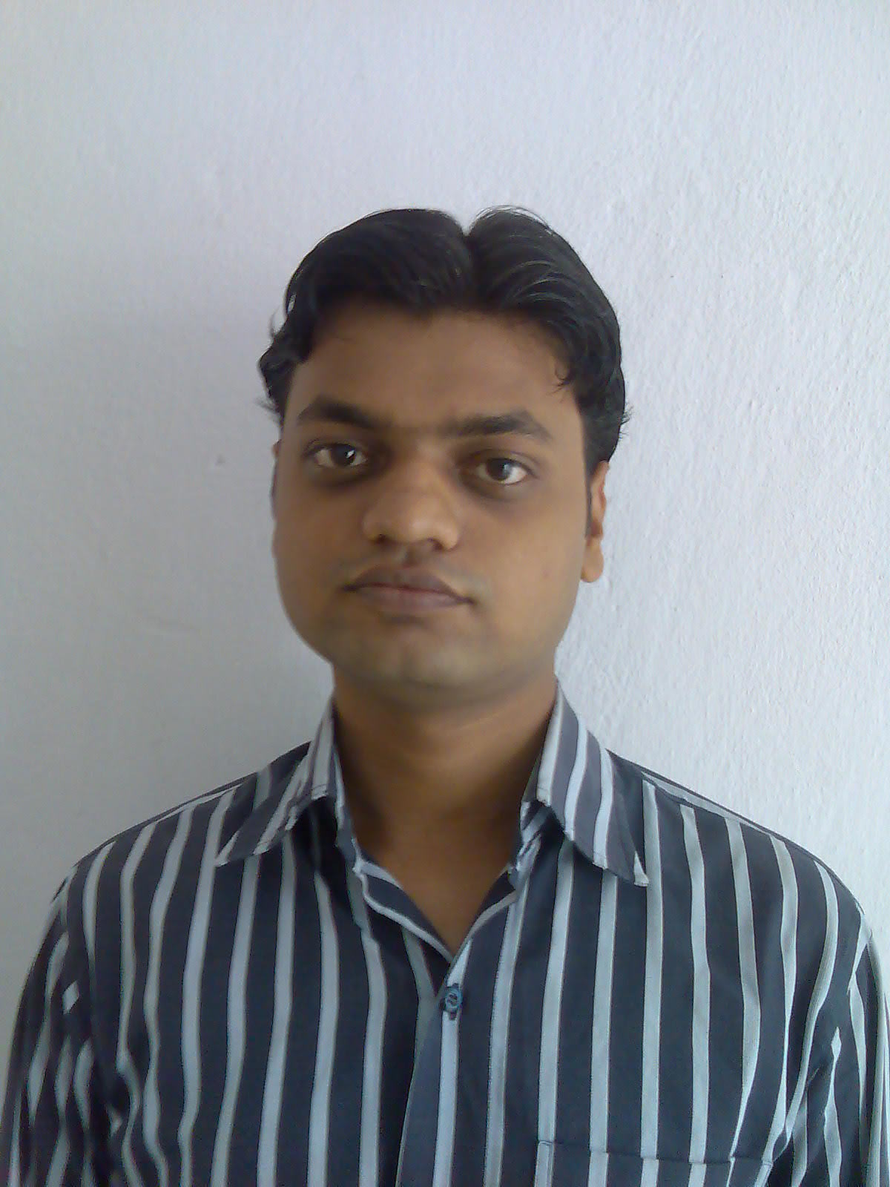
Affix one Recent Passport Size Photograph here
(Scan for softcopy)
Name (in full & in block letters) | : | AMARNATH PRASAD
Department | : | INFORMATION TECHNOLOGY
College Roll No. | : | IT/06/J/04

Father's Name |  | : | SRI GENDLAL PRASAD
Residential Address |  | : | C/O:BRITISH ENGLISH SCHOOL  MANPUR PATWA TOLI DURGA ASTHAN  PO+P.S :BUNIYADGANJ ,GAYA (BIHAR)  PIN:823003
Telephone No. (Preferably Mobile) |  | : | 09233395371,09933590013
E-mail Address (Only one) |  | : | Amarcemk04@gmail.com
Date of Birth |  | : | 15/01/1988
Categories |  | : | OBC
Educational Qualification |  | : | B.TECH(Pursuing)
Examination, Board | School / College, Place |  |  |  | Year of Passing | Total Marks obtained |  | Percentage
Bihar School Examination  Board,Patna | Mahavir Inter College,Gaya |  |  |  | 2002 | 437 |  | 62.42
Bihar Intermediate Education  Council,patna | Maa Bageshwari Inter College,Gaya |  |  |  | 2004 | 511 |  | 56.77
J.E.E. Rank | 13280
B.Tech.( Information Technology) | Semesters |  |  | Year of Passing |  | SGPA | Average B.Tech SGPA (Till Date)
B.Tech.( Information Technology) | 1st |  |  | 2006 |  | 7.33 | 7.416
B.Tech.( Information Technology) | 2nd |  |  | 2007 |  | 7.94
B.Tech.( Information Technology) | 3rd |  |  | 2007 |  | 7.37
B.Tech.( Information Technology) | 4th |  |  | 2008 |  | 7.74
B.Tech.( Information Technology) | 5th |  |  | 2008 |  | 7.08
B.Tech.( Information Technology) | 6th |  |  | 2009 |  | 7.04
B.Tech.( Information Technology) | 7th
B.Tech.( Information Technology) | 8th

Computer Proficiency:
Language | : | C,VISUAL BASIC,CORE JAVA,HTML
RDBMS | : | ORACLE, PL/SQL
Operating Systems | : | WINDOWS X,LINUX

Additional Classes Attended: Vocational Training in HCL INFOSYSTEM LTD

At 29’^{th} june 2009 to 31’st july 2009 on J2EE
Project Undertaken: On web tecnology(ONLINE STUDENT INFORMATION.
SYSTEM) Undertaken In C.E.M.K Is Going On

Extra-Curricular Activities: 1.Co-ordinator Member of NAVPRAYAS (A group of
innovative thought)

2. Participating Member of Inter College Tech-Fest

Hobbies: Playing Computers Game , Listening To Music , Watching
Movies

Date:4-09-2009 | Signature:

