“Hatia gachhi ward no-22  Saharsa Bihar-852201” | Mobile: 9933383674  e-mail: ashutoshcemk10@gmail.com
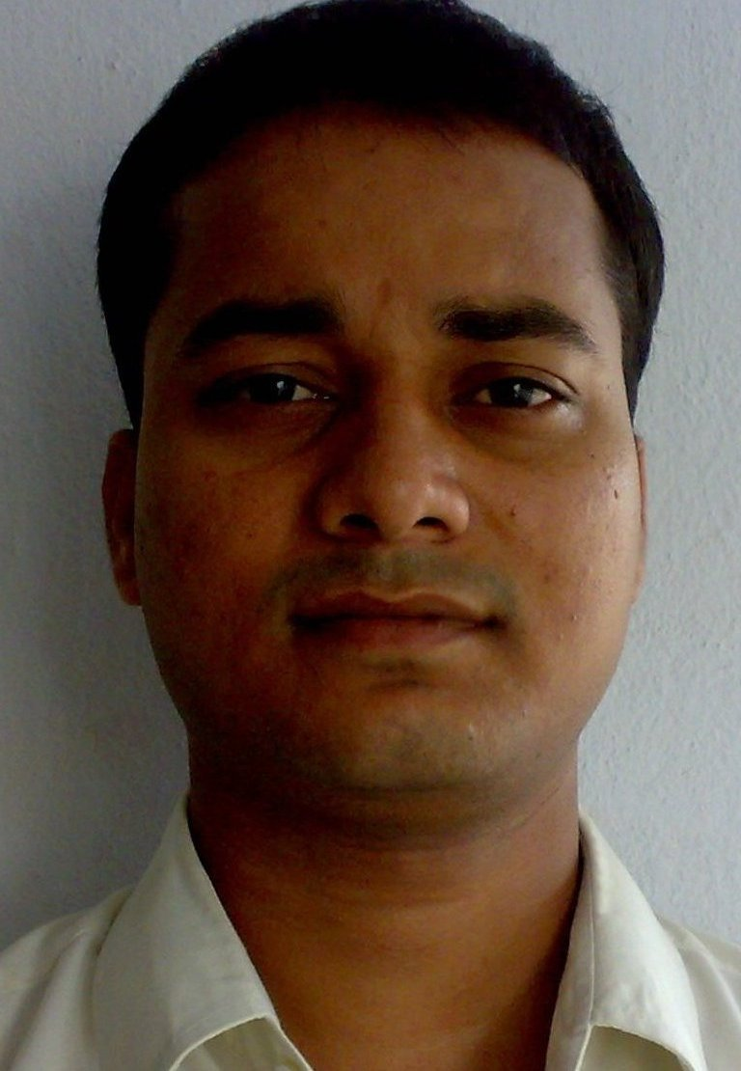

Ashutosh Kumar Chandan
Fresher, pursuing B.Tech in College of Engineering & Management, Kolaghat in Information technology Stream.

Objective:
To grow with the esteemed organization by continuous Up-gradation of New Technology and increasing Performance. I want to be part of a Team where I will be able to Learn, Contribute and Enjoy my work and at the same time add value to my Organization.
Academic Qualification:
Examination | Board | Institution | Year of Passing | Percentage/Grade
Matriculation(10th) | BSEB,Patna | Zila school,saharsa | 2000 | 73.33%
Intermediate in science(12th) | BIEC,Patna | MLT College,Saharsa | 2002 | 58.66%
DCA | Affiliated & Approved by govt. of Bihar | Trimurthy commercial Institute, saharsa | 2004 | 82%
B.Tech1st semester | WBUT | CEM, Kolaghat | 2007 | 8.13
B.Tech 2nd semester | WBUT | CEM, Kolaghat | 2007 | 7.87
B.Tech 3rd semester | WBUT | CEM, Kolaghat | 2008 | 7.13
B.Tech 4th semester | WBUT | CEM, Kolaghat | 2008 | 8.3
B.Tech 5th semester | WBUT | CEM, Kolaghat | 2009 | 7.88
B.Tech 6th semester | WBUT | CEM, Kolaghat | 2009 | 7.85

Projects:
- Project on Telephone Directory on J2EE Platform in HP Salt lake, Kolkata.
- Undergoing academic project “web based school administration system”
- Recently working on a project “online national poling system” by IBM.

Achievements and other co-curricular activities:
- Presently vice president of the college general council.
- Working as a lab teacher in trimurthy commercial institute,saharsa for one year.
- Organizing member of various activities in college(Spandan 09,saraswati puja 07,Resonance 09)
- Participation in various stage show as singer in college.
- Participated in various sports event in college.
- Member of Departmental cricket team
- Active participation in college to organizing “Blood donation camp”.
- NCC ‘B’ certificate holder & ‘C’ certificate awaited
- Clear the EKT exam and staying in the AFSB exam till 5 days
- Achieved first prize in school level Quiz competition.
- Member of Bhartiya scout & guide during my schooling
- Participated in various school level Drama and Poem Recitation competitions events and achieved lot of appreciation and applause.
- Underwent Personality Development courses like “Discover Yourself” and “Positive Thinker” as a part of being a member of a renowned youth group named VOICE.

Personal Details:
Date of Birth | 9th January 1985
Father’s Name | Sri Binod Kumar Das | Marital status | Single | Gender | Male
Nationality | Indian
Languages known | Hindi, English,Maithili and Bengali
Religion | Hinduism
E-mail | ashutoshcemk10@gmail.com.
Address | Hatia Gachhi ward no-22,saharsa Bihar-852201
Mobile No | (0) 9933383674
Skills: | Details
Software | C,JAVA,J2EE,HTML,XML,SQL
OS | MS-DOS ,Windows 9x/XP/7/vista, Linux/unix
Other | Networking, DBMS
Job Experience: | Fresher

Hobbies:

Browsing through Internet.

Working with Computers.

Attending Get-togethers.

Reading spiritual books and also good literatures in hindi and english.

Cooking.

Playing cricket,chess,Badminton

Poetry, singing.
- Making Friends

Social service.

References:
1. Prof S. L. Dutta (Director) –CEMK
2. Prof. Jaydev Mishra (HOD –Cse & IT dept) - CEMK
3. LT. COL.S.R.Bhattacharya(Students affairs)- CEMK

Declaration:
I ASHUTOSH KUMAR CHANDAN hereby declare that all the statements made in this resume are true, complete and correct to the best of my knowledge and belief.

Place:- Kolaghat Date:- 09-02-10 Signature:-

