CURRICULUM VITAE
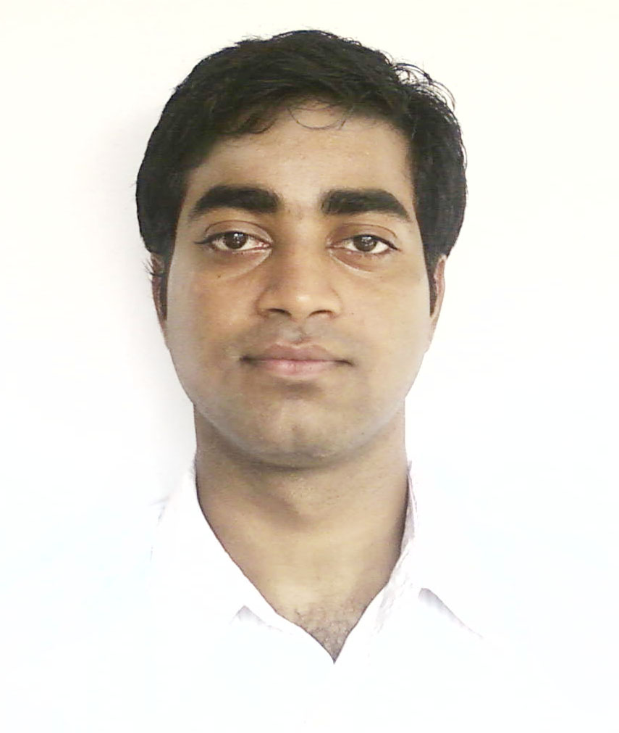

ARINDAM SARDAR

e-mail : fukan47@gmail.com
Contact No : 09735280916

Objective
To grow along with the development of the organization & to continue my level best for this development

About Me
I am energetic and ever ready to explore newer perspectives. I love working in teams and Interested in working on problem-specific jobs, which offer newer challenges and creativity

Personal Information

Date of Birth: 22nd February, 1989

Father’s Name: Shri Prakash Chandra Sardar
Permanent Address: vill+PO-Tangrakhali, PS-Canning, Dist-24 Pgs(S), PIN-743329, WB

Sex: Male, Category: SC, Nationality: Indian

Academic Qualification

Present Course: B.Tech in Information Technology

Institution: College of Engineering & Management, Kolaghat (C.E.M.K.)
University: West Bengal University of Technology (W.B.U.T.)
Course Period: 2006 - 2010

B.Tech Semester Grade Point Average (SGPA)
8th Sem | 7th Sem | 6th Sem | 5th Sem | 4th Sem | 3rd Sem | 2nd Sem | 1st Sem | Cumulative Grade Point Average
NA | NA | 6.48 | 7.15 | 7.11 | 6.20 | 7.42 | 6.80 | 6.86

Schooling
Name of the Examination | Name of the Institution | Board | Year of  Passing | Marks  Obtained
Higher Secondary | Canning David Sassoon High School, Canning Town | W.B.C.H.S.E. | 2006 | 64.90%
Madhyamik Pariksha | DO | W.B.B.S.E. | 2004 | 78.50%

Project Work Experience
Name | Description | Organization
Summer Vocational Training | A project on  ‘Online Banking System’  ( using ASP.NET 2.0 ) | HCL Infosystems Ltd.  (HCL Career Development Centre)  Kolkata
4th year Project  (Active) | ‘Vague Query testing’  ( Using Fuzzy Set  & Vague Set ) | Under the supervision of  Prof. Jaydev Mishra  (HOD of CSE & IT, CEMK)

Computer Skills

Language proficiency: C, Java, JavaScript, HTML, PL/SQL
Operating Systems: Windows-XP/vista/7, linux-debian
Database Management: MS Access, Oracle

Subject Interests: Networking, Web Technology, Operating System

Language Proficiency: Bengali, English

Hobbies: Bicycling and exploring unknown ways, Playing Carom, Playing and Collecting Computer Games, Finding better functionalities in newer softwares

Extra Curricular Activities: NCC, Bratachari, Painting, Gaming

All the information furnished above is true and correct according to my knowledge and belief.

Place: Kolaghat Signature:
Date: 1st January, 2010 ( Arindam Sardar )

