BIO-DATA
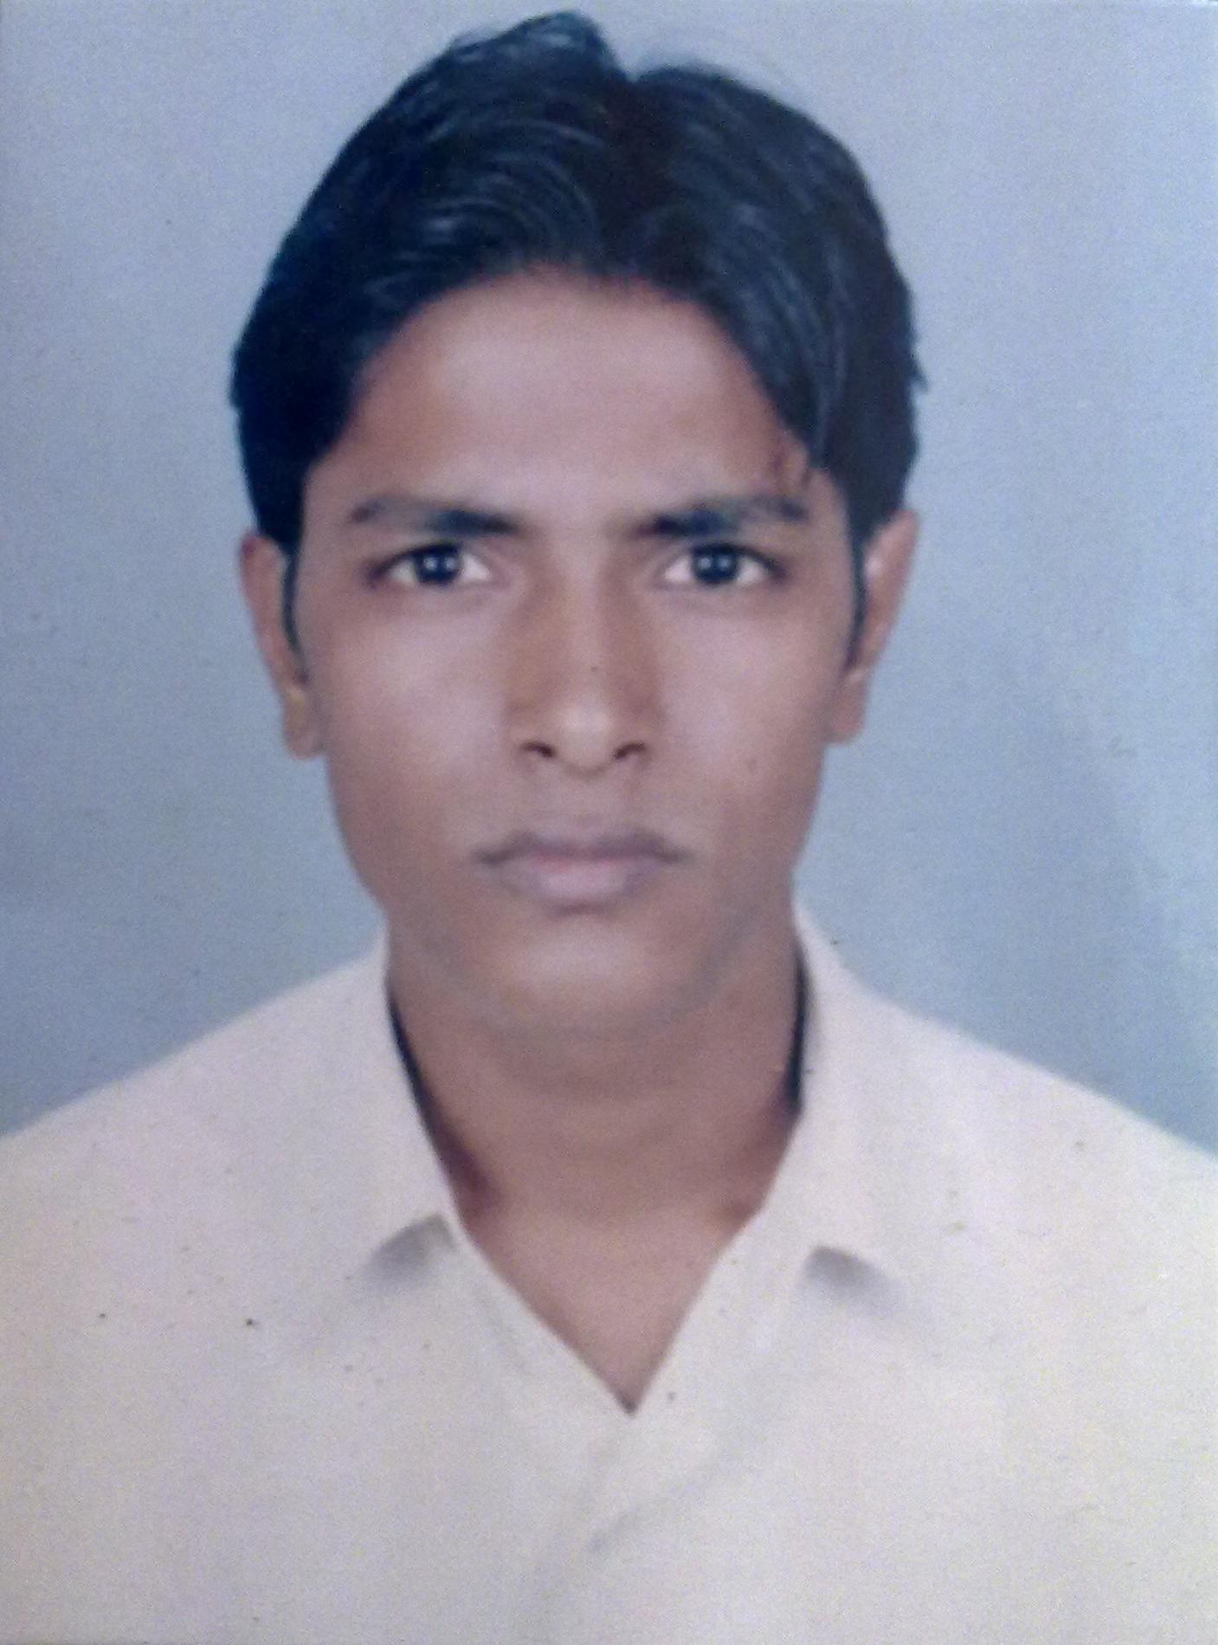
Name (in full & in block letters) | : | AMAR KUMAR
Department | : | COMPUTER SCIENCE AND ENGINEERING
College Roll No. | : | CS/06/A/54

Father's Name |  | : | DHARMDEV SINGH
Residential Address |  | : | VILL-NADI  POST-MURARI  DIST-ARWAL  PIN CODE-804419(BIHAR)
Telephone No. (Preferably Mobile) |  | : | 09002468054
E-mail Address (Only one) |  | : | amarcemk@gmail.com
Date of Birth |  | : | 30/04/1986
Caste |  | : | OBC
Educational Qualification |  | :
Examination, Board | School / College, Place |  |  |  | Year of Passing | Total Marks obtained |  |  | Percentage
B.S.E.B. PATNA BIHAR | G B H SCHOOL DAYALBAG NEHALPUR,JEHANABAD |  |  |  | 2001 | 512/700 |  |  | 73.1%
B.I.E.C. PATNA BIHAR | D N COLLEGE,MASAURHI, PATNA |  |  |  | 2002 | 489/900 |  |  | 54.33%
Diploma Marks
A.I.E.E.E. Rank | 48594
B.Tech.( Department) | Semesters |  |  | Year of Passing |  |  | SGPA | Average B.Tech SGPA (Till Date)
B.Tech.( Department) | 1st |  |  | 2007 |  |  | 6.93 | 6.94
B.Tech.( Department) | 2nd |  |  | 2007 |  |  | 7.39
B.Tech.( Department) | 3rd |  |  | 2008 |  |  | 6.83
B.Tech.( Department) | 4th |  |  | 2008 |  |  | 7.48
B.Tech.( Department) | 5th |  |  | 2009 |  |  | 6.46
B.Tech.( Department) | 6th |  |  | 2009 |  |  | 6.59
B.Tech.( Department) | 7th
B.Tech.( Department) | 8th

Computer Proficiency:

LANGUAGE | : | C,C++,JAVA
WEB DESINING | : | XML,HTML,JAVA SCRIPT,JSP,SERVLET,JDBC
TOOLS & PACKAGES | : | NET BEAN,MS OFFICE,MATLAB,PSPICE
RDBMS | : | SQL,MYSQL,ORACLE
OPERATING SYSTEM | : | WINDOWS XP/VISTA/DOS  LINUX/ UNIX FEDORA/SUSE/DEBIAN/RED HAT/MANDRIVA

Additional Classes Attended: J2EE training at HCL in Summer Project.

Project Undertaken: Block matching algorithm for video coding undertaken C.E.M.KOLAGHAT.

Extra-Curricular Activities:
- Active member of technical fest “RESONANCE 2008” & cultural fest “SPANDAN 2009” .

Hobbies:
- Playing and watching cricket match,badminton,chess.
- Listen to soft music,collecting software.

