RESUME
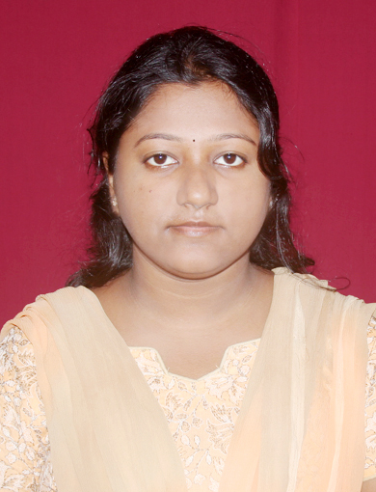
__________________________________________________________________________________________
MADHUSMITA BEHERA
Computer Science
DRIEMS, Cuttack (Orissa)
Address: -
C/o-Mr.Goura Chandra Behera
At/po –Old cinema hall road, laxmi bazar
Dist- Dhenkanal.
E-mail:- madhusmita58@gmail.com
___________________________________________________________________________________________

OBJECTIVES: - To learn and develop excellence in my professional field by exposing myself in challenging jobs.

TECHNICAL QUALIFICATION
SEMESTER | 1st |  | 2nd | 3rd | 4th | 5th | 6th | 7th | 8th | CGPA Upto  8th SEM
SGPA | 6.39 |  | 6.11 | 6.62 | 6.14 | 6.19 | 6.46 | 6.58 | 6.96 | 6.5
UNIVERSITY |  | BPUT

ACADEMIC QUALIFICATION
NAME OF THE EXAMINATION | BOARD/UNIVERSITY | YEAR OF PASSING | PERCENTAGE
12th BOARD | C.H.S.E.ORISSA | 2005 | 45
10th BOARD | B.S.E ORISSA | 2003 | 75.5

COMPUTER SKILLS:-

- Basic Knowledge of C&C++

ACHIEVEMENTS:-

- Awarded 2nd position in District Level painting competition on the occasion of Thinking Day Ceremony.
- Awarded 3rd position in painting competition on population Day by D.I.E.T

PERSONAL STRENGTH:-

- Comprehensive problem solving abilities, ability to deal with people diplomatically willingness to learn. Team facilitator and hard worker.
- Optimistic, dedicated, honest and co-operative.
___________________________________________________________________________

PERSONAL PROFILE

FATHER’S NAME : Mr. Goura Chandra Behera
DATE OF BIRTH : 22-05-1988
LANGUAGES KNOWN : English, Hindi, and Oriya
MOBILE NO : 9861833901
HOBBY : Listening songs & Painting

___________________________________________________________________________

DECLARATION: - I hereby declare that all the information given above is true and best of my knowledge and belief.

DATE:-
PLACE: - MADHUSMITA BEHERA

