CURRICULUM VITAE

LITAN CHANDRA PAUL (ME in Software Engineering)
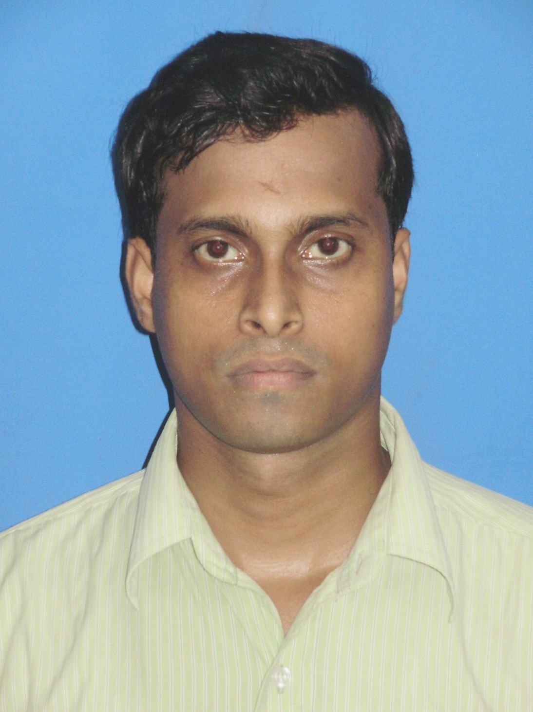
Contact Information:
LITAN CHANDRA PAUL,
Room No.-N2-24
JUSL campus hostel,
Block LB,
sector-III,
Kol-98.

Email: litan_paul@indiatimes.com
Paul.litan.me@gmail.com

Contact No.: +919051750577

OBJECTIVE:
To work in a challenging and creative environment where I can learn and uplift my abilities in the application field of software development process and can do something creative and innovative things in that field. I want to see myself in a reputed software company, where I can emerge myself as successful and efficient software personnel.

Experience:

Name of Organization | Designation | From | To | Place of Posting | Role
Educomp Solutions Limited | Sr. Computer Faculty | 1st September,2004 | 15th June, 2008. | Bishramganj H.S. School, Tripura(West). | Teaching Computer Subjects in a Govt. H.S. School.

EDUCATIONAL QUALIFICATIONS:
QUALIFYING DEGREE | INSTITUTION |  | BOARD/  UNIVERSITY |  | AVERAGE  MARKS |  | YEAR OF PASSING
MADHYAMIK  (CLASS X) | KHASH CHOWMUHANI  CLASS -XII SCHOOL |  | T.B.S.E |  | 63.2 % |  | 1996
HIGHER SECONDARY  (CLASS XII) | BODHJUING HIGH SECONDARY SCHOOL |  | T.B.S.E |  | 65.8 % |  | 1999
BE  (COMPUTER SCIENCE & ENGG.) |  | TRIPURA ENGG. COLLEGE  (Now NIT Agartala) |  | TRIPURA UNIVERSITY |  | 65% |  | 2003
M.E(Pursuing)  (SOFTWARE ENGG.) | JADAVPUR UNIVERSITY |  | JADAVPUR UNIVERSITY |  | 8.07(CGPA)  (Till Last sem.) |  | 2010

TECHNICAL SKILLS:
  - Operating Systems : MS-DOS, WINDOWS 2000/XP
  - Languages : C, C++,SQL
  - Technical Subject : Data Structure, software Engg.

PROJECT:

Project Title: Intranet Mail server

Language Used: HTML, JAVA SCRIPT,VB SCRIPT,ASP,SQL

Description: In this project we have developed a mail server for local area network.

Training: ½ Month Vocational Training on Computer Network in NIC (National Informatics Center), Agartala.

ACHIEVEMENT:

Qualified in GATE-2008 in Computer Science and Engineering.
GATE Score 347, Percentile 89.25.

PERSONAL DETAILS:

- NAME : Litan Chandra Paul
  - FATHER’S NAME : Radha Madhab paul
  - DATE-OF-BIRTH : 02-01-1980
  - LANGUAGES KNOWN : English, Hindi, and Bengali.
  - MARRITAL STATUS : Single
  - HOBBY : Listening Hindi & Bengali Music, watching cricket
  - PERMANENT ADDRESS : VILL-WEST DUKLI, P.O-MADHUBAN
AGARTALA, TRIPURA [WEST], PIN-799003

I solemnly declare that the statements made by me in this form are correct to the best of my knowledge and belief.

LITAN CHANDRA PAUL

