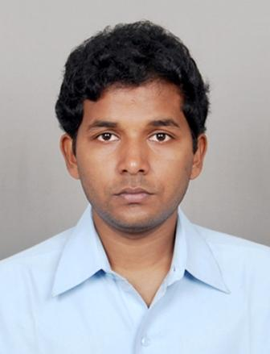
ANIRUDDHA SINHA

14/1,”ANUVILA”,B.N.Ghosal Road
Choudhury para, Belghoria, Kolkata-700056
Telephone no.-+919434637042
E-mail: aniruddhasinha2008@gmail.com
Alternate E-mail: aniruddhasinha1985@gmail.com

CAREER OBJECTIVE: To be a member of a competitive yet professional organization where the work would give me mental satisfaction and I can prove myself as an asset to the organization.

PROFESSIONAL QUALIFICATION:
■ Passed MCA (Masters in Computer Application) from Bengal College of Engineering & Technology, Durgapur under West Bengal University of Technology in the year 2010 with D.G.P.A. 8.28.

■ Taken Training in CORE JAVA under ARDENT COLLABORATION, Kolkata.

■ Completed a Sun Educational Services course in Sun Java Programming Language under SCORE Tech Vision.

COMPUTER PROFICIENCY:
Languages : C, C++, C#, Core Java, SQL.
Operating System : Windows (Server 2008 and XP).
Databases : SQL Server 2005, Oracle 9i
Web Technology : Asp .Net, Java Script.
Web Designing : HTML, CSS.

PROJECT DETAILS:
- FastSourceWorld.com Duration : In Progress

Type : Freelancing Product.
Role : Developer.
Technologies : ASP.NET, C#, .Net framework 3.5, SQLServer2005,
Java Script, Asp.net Ajax Controls.
Designing : Abode Photoshop 7.0, Cascading Style Sheet.
Description : It is an online educative and knowledge developing forum and
tutorial website. In this site registered members can download
tutorials of different computer languages.
Responsibility : 1. Project analyzing, Coding.
2. Unit Testing of Systems.
URL : http://www.fastsourceworld.com/

ACADEMIC QUALIFICATION
- Passed BCA (Bachelors in Computer Application) from B.P.Podder Institute of Management & Technology under West Bengal University of Technology in the year 2007 with D.G.P.A. 7.46.

- Passed Higher Secondary Examination from WBCHSE in the year 2004 with 49.50%.

- Passed Madhyamik Examination (SSC) from WBBSE in the year 2002 with 65.38%.

HOBBIES:

- Extensive Traveling
- Making new Friends
- Watching and playing cricket
- Listening Music

PERSONAL DETAILS

Fathers Name Mr.S.K.Sinha
Sex Male
Marital Status Unmarried
Religion Hindu
Nationality Indian
Date of Birth 02 Feb 1985
Languages known English, Hindi, Bengali
Permanent Address ASAMAPIKA, Dangali kali tala, Bolpur, Birbhum, (WB)

SOMETHING ABOUT MYSELF: I am a very optimistic person who has a great zeal for hard work and loves to face the various challenges life has to offer.

I hereby declare that the above given information is true to best of my knowledge.

DATE

-------------------------------------
KOLKATA Aniruddha Sinha

