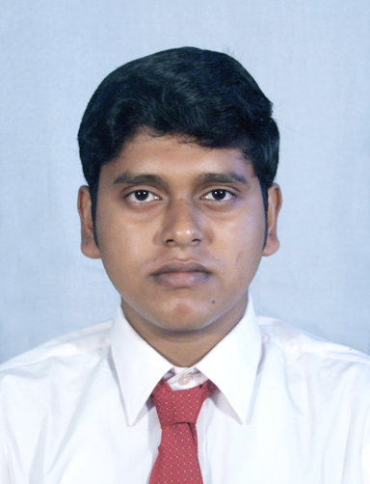
Mr. Tanumoy Bose ADRESS : P.O. MICHAEL NAGAR DIST: 24 P.G.S.(N) KOLKATA 700133 WEST BENGAL,INDIA E-MAIL ID : tanumoybose1986@gmail.com CONTACT NO : 03325674806/9903131718
___________________________________________________________________________________________________________________________________________________________________________________________________________________________________________________________________________________________________________________________
Objective

- Seeking an entry-level position in the area of software development in a fast-paced organization to utilize my abilities and skills in the Information Technology Industry that offers professional growth while being innovative, resourceful, and flexible. Ready for immediate relocation, if required.
Personal Skills

- Highly focused, sincere and willingness to learn.
- Ability of hardworking in any conditions and situations.
- Punctuality and meet the deadlines.
Current Status

A B.Tech student of Information Technology from B.P.PODDAR INSTITUTE OF MANAGEMENT AND TECHNOLOGY, Kolkata-52, affiliated by WEST BWNGAL UNIVERSITY OF TECHNOLOGY.
Academic Details

Name of the exam | Name of the  Board/University | Name of the  School/Institution | Semester | Year of  Passing | Marks/  SGPA
B-Tech (Information Technology) | W.B.U.T. | B.P. Poddar Institute of  Management  And  Technology | 1st | 2006 | 6.86
B-Tech (Information Technology) | W.B.U.T. | B.P. Poddar Institute of  Management  And  Technology | 2nd | 2006 | 7.68
B-Tech (Information Technology) | W.B.U.T. | B.P. Poddar Institute of  Management  And  Technology | 3rd | 2007 | 7.47
B-Tech (Information Technology) | W.B.U.T. | B.P. Poddar Institute of  Management  And  Technology | 4th | 2007 | 8.56
B-Tech (Information Technology) | W.B.U.T. | B.P. Poddar Institute of  Management  And  Technology | 5th | 2008 | 6.69
B-Tech (Information Technology) | W.B.U.T. | B.P. Poddar Institute of  Management  And  Technology | 6th | 2008 | 7.63
B-Tech (Information Technology) | W.B.U.T. | B.P. Poddar Institute of  Management  And  Technology | 7th | 2008 | 8.00
B-Tech (Information Technology) | W.B.U.T. | B.P. Poddar Institute of  Management  And  Technology | 8th | 2009 | 8.73
B-Tech (Information Technology) | W.B.U.T. | B.P. Poddar Institute of  Management  And  Technology | DGPA |  | 7.71
Higher Secondary (12th) | W.B.C.H.S.E | Madhyamgram  High School |  | 2004 | 60.5%
Madhyamik (10th) | W.B.S.E. | Madhyamgram  High School |  | 2002 | 78.75%

Software proficiency

- Programming Language: C,VB.Net and Core Java
Major Subjects

- Data Structure using C, DBMS, Software Engineering.
Communication Skill

- Bengali (Read, Write and Speak)
- English (Read, Write and Speak)
- Hindi (Read, Write and Speak)
Personal Profile

FATHER’S NAME : Tamal Kanti Bose
D.O.B. : 13th March, 1986 SEX : Male NATIONALITY : Indian (by birth)
Hobbies

Playing Cricket and Football
Experience

Nearly two and half months of experience in Social Media field in Webicontechnologies . I have done Account Creation in various Social Networking Websites, Blog Posting, Journal Posting, Video Uploading ,Picture Uploading, Account Modification, Scrap Posting, Friends Making, Book Marking etc.
Declaration

I, hereby declare that all the information made above are true and correct to the best of my knowledge and belief.

Dated:_________________ Signature : _____________________ Place: Kolkata (Tanumoy Bose)

