Partha Bhattacharjee

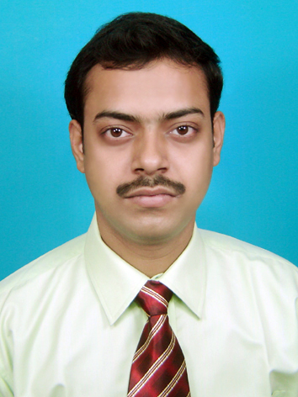
* : parthabhattacharjee.3g@gmail.com
(: 9836035183(M)

Career Objective

To pursue a challenging career and to enhance my knowledge base, while contributing effectively to the organization. Further, to work in a team, work closely with clients and developing best practices using unconventional and innovative ideas and methods.

Key Strengths

    - Possess strong commitment to team dynamics with the ability to contribute expertise and follow leadership directives at appropriate times.
    - Focused and enthusiastic to complete the given assignments.
    - Confident with right perception and ability to motivate others.

Summer Project

COMPANY NAME : IMRB International, Kolkata
PROJECT TITLE : Agent Satisfaction of Max NewYork
Life Insurance
PROJECT DESCRIPTION : To measure the satisfaction level of the agents
Of Max NewYork Life Insurance Company
PROJECT DURATION : 1 month and 15 days

Academic Qualification

MBA(pursuing)
Future Institute Of Engineering and Management affiliated to West Bengal
University of Technology.
Major Specialization: Marketing
Minor Specialization: HR
YGPA-7.19

B.Sc (Chemistry Hons.)
Maulana Azad College affiliated to Calcutta University.
Degree Percentage = 46.12%

I.S.C 12th – (Science)
Krishnagar Academy affiliated to The Council For Indian School Certificate
Examinations, New Delhi. Total Percentage = 86.6%

I.C.S.E 10th -
Krishnagar Academy affiliated to The Council For Indian School Certificate
Examinations, New Delhi. Total Percentage = 80.8%

COMPUTER PROFICIENCY

ERP Programme : Microsoft Dynamics® NAV 2009 (pursuing)

Operating Systems : Windows XP, Windows Vista, Windows 7
Tools : Computer basics , Internet Application-------------------------------------------------------------------- (DOEACC SOCIETY,KOLKATA CENTRE, JU CAMPUS).

Additional Information

Fluent in English, Hindi and Bengali.
Personal interests include Reading, Painting, Watching Movies.
Interacting with People, listening to good music.
Playing Tabla.

Personal Details

Father’s Name : Mr. Paritosh kumar Bhattacharjee

Mother’s Name : Mrs. Dipti Bhattacharjee

Date Of Birth : 5th July, 1986

Permanent Address : Bowbazar, Aurobindo Road,
P.O. Krishnagar, Nadia,
Pin: 741101

Blood Group : B^{+ ve.}

Gender : Male

Religion : Hindu

Languages Known : English, Bengali, Hindi

Declaration

I hereby declare that all the above information are true and correct to the best of my ---------------------- knowledge.

Partha Bhattacharjee

Dated:
Place: Kolkata

