CURRICULUM VITAE
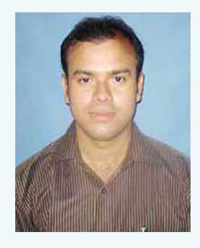
Name : Raju Alam
Date of birth : 24-03-1984 ( dd-mm-yyyy)
Nationality : Indian.
Strengths : Quick Learning and Hard Working.
Height : 5’6”
Weight : 67.5 Kgs.
Address : C/O- Sahanuyas Alam,
Haroa, Dist – North 24 Parganas,
West Bengal , Pin – 743445
Contact No : Mobile – 8436583000 , 9563747070,
E-mail – rajualam123@gmail.com

Academic Qualification :

School/  College | Board/  University | Year | Examination | Division | Percentage
Gopalpur  Papular  Academy | W.B.B.S.E | 1999 | Madhyamik | 2 nd | 52 %
Gopalpur  Papular  Academy | W.B.C.H.S.E | 2001 | Higher  Secondary | 2 nd | 50 %
Basirhat College | C.U | 2004 | B.A | 2 nd | 45 %
R.B.U | R.B.U | 2006 | M.A | 2nd | 42%

Professional Qualification :

Course | Institute | Duration
My Website.com | Brainware Computer Academy | 04 Months
Swift Joyti | NIIT | 03 Months
D.I.T.A | Rush Computer Centre | 06 Months
D.W.C | NIIT | 12 Months
D.T.P | Brainware Computer Academy | 12 Months
Windows.net | NIIT | 01 Month
Hardware | Nathpoint | 03 Months
Hardware | Youth Computer Center | 06 Months
Networking | Britech Computer Academy | 06 Months

Details of Computer Knowledge :

Operating System : Windows, Dos, Linux, Windows Server
Software Package : MS Word, MS Excel, MS Powerpoint, MS Frontpage, Adobe Pagemaker, Coreldraw, Adobe Photoshop, MS Foxpro, Gist, Toptype, Bijoy .
Internet : E-mail, Chat, Surfing, Web Hosting, Upload, Download.
Others : HTML.
Job Experience : 1) 3 years job experience from Compumantra Computer Academy as a post of faculty.

2) 4 years practical experience about Computer Hardware.

3) 01 Year practical experience about Computer Network.( LAN)

4) 02 Year job experience from Baduria Youth Computer Training Centre , working as a post of faculty .

Hobbies : Surfing Internet.
Language Efficiency : English, Hindi, Bengali.
Expected Salary : Negotiable

I here by declare that the details given are correct to the best of my knowledge.

Date :- Yours Faithfully

Place : Haroa Raju Alam

