RESUME
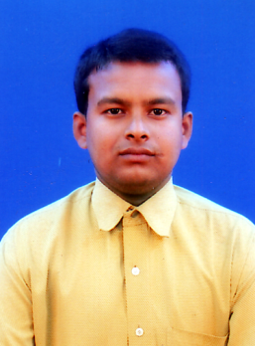
PARTHA DEBNATH
N/3/1 Ramkrishna pally
Benachity,Durgapur
Burdwan, West Bengal
Pin-713213

E-mail: partha_deb123@rediffmail.com

MOBILE- +91-9800934004

CAREER OBJECTIVE

To do challenging work that effectively utilizes my academic credentials and professional Expertise.

.

EDUCATIONAL QUALIFICATION

NAME OF THE  EXAMINATION | BOARD/UNIVERSITY | YEAR | PERCENTAGE  %
Graduation | Burdwan University | 2007 | 43%
Higher secondary | West Bengal Council of  Higher secondary Education | 2004 | 50%
secondary | West Bengal Board of  Secondary Education | 2002 | 58%

EXPRIENCE AND ACHIEVEMENT
- one year worked in Vodafone as a sales executive.(02/02/2006 to 25/08/2006).

- 3 years worked in HINDUSTAN UNILEVER LTD.Durgapur-713213, as a sales executive. (16/07/2007 to 1/2/2010).

- Currently working Larson & toubro ltd as a sales officer .(2/2/2010 TO TILL NOW)CTC-8,000 p/m

JOB PROFILE

1.Handling different Dealers & Distributers.

2.Prepare requisitions.

3.Handling the Stocks.

4.Manage the primary & secondary Sales.

5.Handling the accounts of the Distributors.

6.Promoting the Sale.

7.Planing the Activities of whole month

8.Day to day Reporting by creation DSR.

9.Achive the Target as per month.

IT SKILL

Friendly with DOS, WORD,MS EXCEL, & INTERNET

PERSONAL DETAIL

Father name: TARAK DEBNATH
Date f birth: 28 JUNE 1986
Nationality: Indian
Sex: Male
Matarial status:single

LINGUISTIC PROFICIENCY

READ | WRITE | SPEAK
English | English | English
Bengali | Bengali | Bengali
Hindi |  | Hindi

INTEREST

Playing Cricket, Listening Music, Traveling

DECLARATION
I hereby declare that the above information is true to the best of my
Knowledge.

DATE:

PLACE: ____________________________

signature

