RESUME

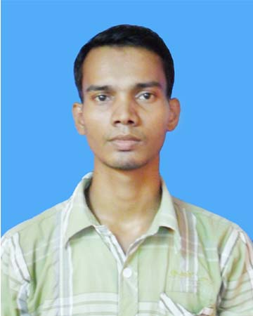

JYOTIRMOY DAS
Vill-Choto Jirakpur(swasti colony)
Dharmadas Road
P.O-Basirhat(R.S)
P.S-Basirhat
Dist-24 PGS(N)
Pincode-743414
State-West Bengal.
Contact no: 9233034388 .
Email Id: jmd.jyotirmoy5715@gmail.com

Objective:
Seeking a challenging position in IT industries where my skills and knowledge can be best utilized.
Academic Qualifications:
Degree | Institute | Board/University | Year of Passing | % / CGPA
Msc(Computer Science) | - | RKM Vivekananda University Belur Math | 2014 | 7.2(upto 3rd sem)
B.Tech(Computer Sc. & Engg) | Narula Institute of Technology | WBUT | 2011 | 78.60
12 th | B.T Sir RHS | WBCHSE | 2007 | 73
10 th | B.T Sir RHS | WBBSE | 2005 | 81.75

Software Exposure:
Operating System : Windows , Linux(Fedora, Debian).
Languages Known : C, , Java, HTML, PHP, ,Shell programming,.
Databases : ORACLE 9i, MYSQL
Packages : Ms-Office2007

Project

Undergraduate:
Online E-PostOffice
Platform: J2EE ,MS-Access

Subjects of Interest:

- Operating System,DBMS,Mathematics, Graph Theory.

Hobbies :Music , watching movies. serials
Personal Details:
Name : Jyotirmoy Das
Father's Name : Chandi Charan Das
Date of Birth : 5 th March 1987
Status : Single
Languages Spoken : Bengali(Mother Tongue) , English and Hindi.
Declarations:

I do hereby declare that all the information provided above is true to the best of my knowledge and understanding.

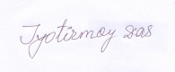
Place:BELUR MATH

Date :30/12/2013 (Signature)

