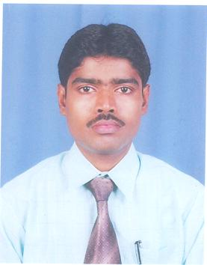

Vill +Po: Fatepur
P.S: Falta,
Dist: 24Pgs (South),
West Bengal.743513
Mobile: +91 9002343866
BIKASH KUMAR BAG Email: bikash.kr.bag08@gmail.com

Preferred Industry- Hospital / Healthcare

To seek challenging assignments and responsibilities and be a source of strength and dedicated to whomsoever I may be working within the filed of my application leading to both professional and personal growth.

Professional Profile

- Presently associated with Hosmac India Pvt. Ltd as a Management consultant and responsible for implementation of Quality Management System at Raiganj District Hospital (WB).
- Experienced as a TPA coordinator with Bhoumick Associate (associated with BM Birla Heart Research Centre, CMRI, EEDF and others) since 1st Dec 2008 to 31st Dec 2010.
- 6 month of work experience as a floor manager of HLG Memorial Trust & Charitable Hospital (WB) [1st May 2008 to 24th Nov 2008]
- Practicing Physiotherapy since year 2004 till the date.

Certification

- Passed ISO9001:2008 Internal Auditor Course from TUV India………… 2011
- Passed Lead Auditor course on ISO 9001:2008 (Quality Management System Requirement) standard from Brtish Standard Institute………. 2009

IT Proficiency

- Microsoft Office & Internet

Academic Profile
Pursuing PGDHM (Distance)
- Bachelor in Hospital Management (WBUT) 2008
- Physiotherapy from WBSCTE 2004
- Bachelor In Commerce (Calcutta University) 2002
- Intermediate from WBHSCE 1998
- Matriculation from WBBSE 1996

Industrial Training

- Two months Industrial training in Christian Medical College (CMC) Vellore.
- Three months industrial training in Yashoda hospital, secunderabad. (To conform requirements for quality assurance of services as per ISO9001 quality management system requirement standard, reduction of duplication of data recording, carried out gap analysis to achieve W.H.O patient safety goal no-1 to 4)

Area of Expertise

- TPA
- Operation Management
- Quality Management System (ISO 9001:2008)
- Physiotherapy

Personal Profile:

- Date of Birth : 1st of January 1981
- Language known : English (Read-Write-Speak), Hindi (Speak) & Bengali (Read-Write-Speak)
- Hobbies : Searching the week point and improvement ,Playing Outdoor Games and Making Friends

I hereby affirm that all above given information are correct and true.

Bikash Kr. Bag
Date:

