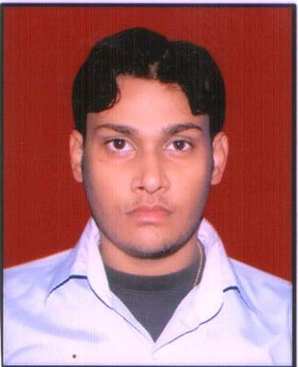

BIJENDER
Vill- Sadarpur Sec-45
Noida-201301
Mob: 9015204551,8527860407
Email id- Vijay.chauhan205@gmail.com

CAREER OBJECTIVE

Seeking a position to utilize my skills and abilities in the Industry that offers professional growth while being resourceful, innovative and flexible.

EDUCATIONAL QUALIFICATION

- Intermediate Passed From U.P Board
- High School Passed From U.P Board

PROFESSIONAL EXPERIENCE AVENU

- Presently Working With Ambience Water Solution & Marketing Ltd As a Office In charge 14/02/2010 in Noida Sec-60

- One Year Worked Experience in Constructions Line As a Supervisor in Raja Garden Today’s Mall West Gate New Delhi

- Eight Month Worked Experience in A.T.S Pvt.Ltd As a Data Entery Work in Noida Sec -18

COMPUTER KNOWLEDGE:
.
- Ms-office

- Internet

- Photoshop

- Data Base

- Corel Draw

EXTRA CURRICULAR ACTIVITIES :

- Listening music and travelling

STRENGTH:

- Good communication skills
- Very hard working and commited to job
- Adaptable to all working environment

PERSONAL PROFILE:

FATHER’S NAME : Shri Jagdish Singh
MARITIAL STATUS : Marriged
NATIONALITY : Indian
SEX : Male
HOBBIES : Bike Reading,
DATE OF BIRTH : 7 -Aug -1990

DECLARATION

I hereby declare that the facts stated above are true & correct to the best of my knowledge.

PLACE:
DATE :
(BIJENDER)

