RESUME
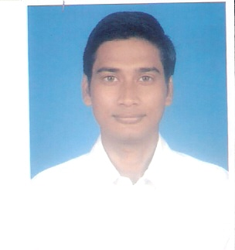
SUBHAMOY MISHRA

16/20, Newton Avenue E-mail:mishrasubhamoy@rediffmail.com
B-Zone, Durgapur Mobile No.: 09832806529
Burdwan, West Bengal
PIN-713205

Objective To make myself stand in the Corporate/ITES world through continuous acquisition of knowledge and implementing the knowledge in best of my capabilities and abilities.

Strength * Diligent person with a positive attitude
* Responsible
Work Experience TSG Global Services Pvt. Ltd.:- Working as an Operations Assistant in the project ESIC under WIPRO’s control since 8th November 2011 to till date and also have a little experience as a Date Entry Operator.

Educational Qualification:
Examination Passed | University / Institution/ Board | Year of Passing | Class / Div. With % | Stream
Graduation | Durgapur Govt. College/ Burdwan University | 2005 | 2nd Div. With 53.93% | Pure Science  (pass)
Higher Secondary (10 +2) | W. B. C. H. S. E | 2001 | 2nd Div. With 57. 20% | Science
Matriculation | W. B. B. S. E | 1999 | 1st Div. With 64. 13% | General

Other Qualification:

- Hardware & PC maintenance from Webel Computer Centre, City Centre, Durgapur-16.
- Medical Transcription training from Universal Medi-Com Transcriber (UM-CT), Durgapur-16.

Knowledge:

- Office (2000/XP/2003).
- Internet.
- Computer typing knowledge (Speed- 35 word/min).
- Good keyboard skill.

Personal Details

Name SUBHAMOY MISHRA.

Father’s Name Mr. Swapan Kr. Mishra

Date of Birth July 03, 1982

Marital Status Single

Gender Male

Category General (Brahmin)

Religion Hinduism

Languages Known Bengali, English, Hindi

Correspondence Address 16/20 Newton Avenue
B-Zone, Durgapur,
Dist-Burdwan, West Bengal
Pin-713205

E-mail mishrasubhamoy@rediffmail.com

Hobbies Net surfing, playing,
Watching TV.

Date:

Place: signature

