CURICULUM VITAE

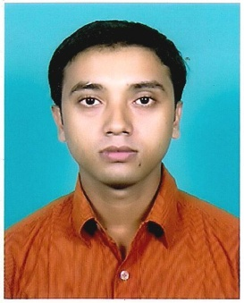

SUKANTA GHOSH e-mail-: ssrocks.2008@rediffamil.com
Sghosh167@gmail.com
Contact No: 9832716509

Career Objective:

To learn, grow and perform in a competitive environment and to utilize my knowledge and technical skills towards the company goals through self-motivation and team work.

Qualification:

Professional Qualification:
- Appearing MCA 6th Semester from Punjab Technical University.

. 2. BCA
- [2007-2010] North Bengal University
B.C.A (Raiganj College)
Scored 57.78%

Academic Qualification:
Sl. No. | Name of the Examination | Name of Institution/Board/Council | Year of Passing | Score
1. | H.S (XII) | RAIGANJ KAILASH CHANDRA RADHARANI UCHCHA VIDYAPITH(H.S)  W.B.C.H.S.E. | 2007 | 58%
2. | MADHYAMIK(X) | DEBINAGAR GAYALAL RAMHARI UCHCHA VIDYAPITH (H.S)  W.B.B.S.E. | 2005 | 65.05%
Other qualifications:

- Diploma in Information Technology Application form Raiganj Youth Computer Training Centre.
- ESDP on Computer Hardware Servicing and Maintenance from MSME.
Work Experience:

- Worked in Tally INSTITUTE as a Computer Teacher.
- Worked in GTFS, I-Nova Marketing Ltd. as a career agent.
- Working as a Part Time Computer Teacher at Raiganj Mohanbati Parbati Debi Balika Vidyalaya in Vocational Stream.

Language Proficiency:

Sl. No. | Languages | Reading | Writing | Speaking | Understanding
1. | Bengali | Yes | Yes | Yes | Yes
2. | Hindi | No | No | Yes | Yes
3. | English | Yes | Yes | No | Yes
About Myself:

Father’s Name : Suresh Chandra Ghosh.
Date of Birth : 23-December-1989
Sex : Male
Marital Status : Unmarried.
Cast : O.B.C.
Nationality : Indian
Address : P.O. + Vill. - Debinagar.
P.S. – Raiganj - 733123
Dist. Uttar Dinajpur (W.B.)

Extra Curricular Activities:

- Participated in March past on the occasion of the 58th Republic Day Ceremony with Civil Defense Boys.
- Participated in the District Science Fair in 2006.

Hobbies:

To interact with people, NET searching & Chatting, Listening of Rabindrasangeet & Gardening.

Declaration:

I do hereby declare that to achieve my goal if I get proper guidance from you I can prove myself and all the information provided by me is true to the best of my knowledge and belief.

Place:
Dated: (Sukanta Ghosh)

