SUBHASIS JANA 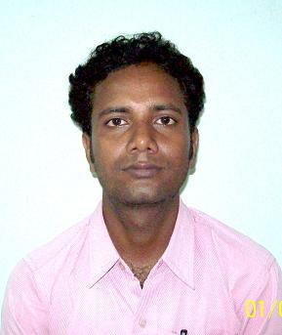
Vill –Ayma, PO – Ganderpukur, PS - Singur
Dist – Hooghly , West Bengal, Pin-712409
E-Mail : subhasisjana_2008@rediffmail.com
Cell no. 9230256046

Key Skill:
Personnel Administration, Civil adminstration, Documentation, Compensation & Benefits, project work.

Extra strength :

Worked on Project from the Green Field having experience of site office, field job, planning & supervising in civil work & reporting to management level .
.
Education:
- E- MBA(HR) passed from Indian School of Management & Studies in 2010.
- B.A. passed from Burdwan University in 2001.
- H.S. passed in 1998.
- Madhyamik passed in 1996 .

Computer Education: Ms office, Ms Excel , Powerpoint , Internet , E-mailing etc. from WEBEL.

Track Record of Carrier:

- Absorb the Position of assistant surveyor on June’2007 to January 2008 at G D Surveyor.
- From February 2008 to March 2012 absorb as an Officer - Administration in Amtek Auto Limited .

Personnel Administration

Handling of functions like Appointment letters,
Salary, PF , Documentation , Satuatory ,MIS , Attendance, Leaves, Employee joining & leaving formalities ,Guest House , Canteen , Cars etc.

General Administration:
Managing the housekeeping activities, security and safety, medical/hospital, Local Police Station etc.

Personal Details :

Father’s Name : Sri Purna Chandra Jana

Marital Status : Unmarried

Date of Birth : 06.01.1980

Permanent Add : As on above

Language Known : English, Hindi, Bengali,

Hobbies: Cricket, Traveling, Public Relation , Gardening etc.

Current CTC:
Expected CTC : Negotiable.
Referred :

Place : Subhasis Jana
Date : Initial

