MAINAK GHOSH
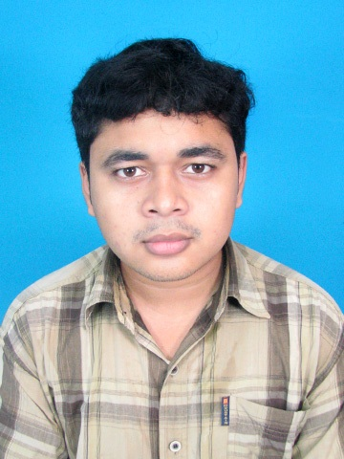

Present & permanent address:

Vill: Taragun,
P.O.- Hoera,
P.S.: Mogra,
Dist.- Hooghly,
Pin- 712147.

Contact Nos.: 9874609945

E-mail: mainakghosh20@gmail.com

CAREER OBJECTIVE

To participate and significantly contribute in attaining the high standards set by the organizations and to meet the ever changing needs of the market.

PROJECT PROFILE

Carried out final year project titled “Microcontroller based temperature monitoring & controling through wireless communication technology”. Main objective of the project is to Design & fabrication of microcontroller based temperature monitoring & controlling system. 1st part of the project is to design & fabricate the circuit for measuring temperature by using suitable temperature sensor, the next part of the project is to design & fabricate temperature transmitter and microcontroller based temperature indication in LCD display by wireless communication system.

VOCATIONAL TRAINING

- Underwent two weeks training on “Application of Instrumentation in Steel Plant” from Durgapur Steel Plant (Steel Authority Of India Limited).

- Underwent two weeks training on Programmable Logic Controller (P.L.C) from ‘IETE’(The Institution of Electronics & Telecommunication Engineers) at Saltlake , Kolkata.

TECHNICAL SKILLS

Subjects of Interest: Digital Electronics, Microprocessor(8085), Industrial Instrumentation, sensor & Process Control.

Computer Proficiency: Conversant with the basics of C programming language, Computer Networking , MS Office- Word, MS- Excel, MS-Power point.

ACADEMIC QUALIFICATION

B.Tech. in Electronics & Instrumentation Engineering :-
SEMESTER | INSTITUTE | UNIVERSITY | CGPA | YEAR | FINAL RESULT
8th Semester | Saroj Mohan Institute of Technology | West Bengal University of Technology | 8.48 | 2011-12 | 7.72
7th Semester | Saroj Mohan Institute of Technology | West Bengal University of Technology | 7.92 | 2011-12 | 7.72
6th Semester | Saroj Mohan Institute of Technology | West Bengal University of Technology | 7.67 | 2010-11 | 7.72
5th Semester | Saroj Mohan Institute of Technology | West Bengal University of Technology | 7.86 | 2010-11 | 7.72
4th Semester | Saroj Mohan Institute of Technology | West Bengal University of Technology | 7.90 | 2009-10 | 7.72
3rd Semester | Saroj Mohan Institute of Technology | West Bengal University of Technology | 7.42 | 2009-10 | 7.72
2nd Semester | Saroj Mohan Institute of Technology | West Bengal University of Technology | 7.16 | 2008-09 | 7.72
1st Semester | Saroj Mohan Institute of Technology | West Bengal University of Technology | 6.83 | 2008-09 | 7.72

Higher Secondary & Secondary:-
EXAMINATION | INSTITUTE | BOARD | YEAR | % MARKS
Higher Secondary (Class XII Science) | Bagati Ramgopal Ghosh High School. | West Bengal Council Of Higher Secondary Education | 2007 | 70.40
Madhyamik  (Class X) | Magra Uttam Chandra High School. | West Bengal Board of Secondary Education | 2005 | 80.12

ACHIEVEMENTS
. Participated in “Inter Engineering College Academic Meet 2012” organized by “FORUM OF SCIENTISTS, ENGINEERS & TECHNOLOGISTS” (FOSET).

- Participated in “Talent Search Test On Geography”, organized by “BANGIYA BHUGOL MANCHA”.

PERSONAL DETAILS

Father’s Name: Sri Tapan Kumar Ghosh.
Date of Birth: 20th April, 1990.
Sex: Male
Nationality: Indian
Language Proficiency: English, Bengali, Hindi.
Interests & Hobbies : Listening to Music, Drawing & Playing cricket.

Date:
Place:
MAINAK GHOSH

