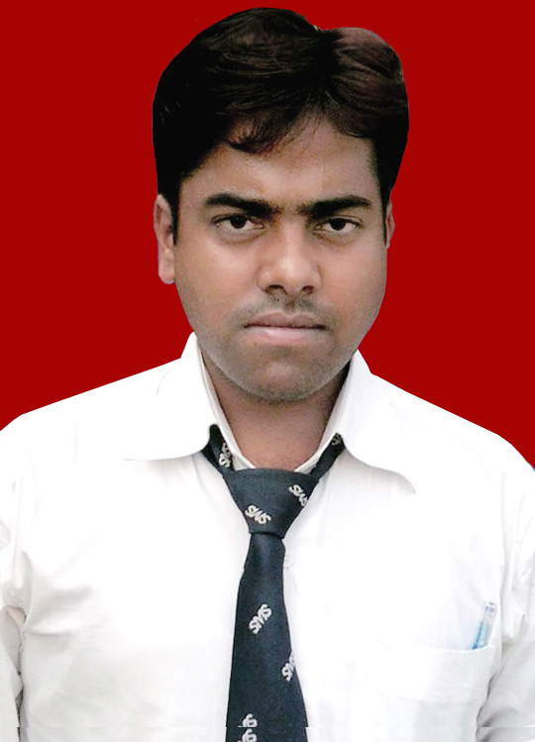

Brijesh Kumar Pandey
email: brijeshpandey53@gmail.com

CONTACT NO. : +91-9415814285

To work with an organization where my skills can be utilized to the fullest and find feasible environment for growth. To add maximum value to the organization, thereby charting a growth path for both the organization and myself
OBJECTIVE

- Appearing Master of Computer Application (M.C.A) from Gautam Budha Technical University (Lucknow) .
EDUCATIONAL QUALIFICATIONS

Graduation:

Passed B.A. 2009 from Dr. R.M.L.A.University Faizabad with

50.66 % marks
- Intermediate:
Passed in 2005 from U.P. board with 62% marks.
- Matriculation :
Passed in 2003 from U.P. board with 45% marks.

- M.C.A. from School of Management Science, Varanasi affiliated to G.B.T.U, Lucknow.
PROFESSIONAL QUALIFICATIONS

- Good understanding of programming logic.
TECHNICAL SPECIALIZATION
- Good concept of Data structure.
- Excellent programming skills in ASP.NET and PHP
- Good knowledge of PHP,HTML,java script,C#,ORACLE, SQL SERVER 2008

- Title – Departmental Store Management System (Semester Project)
PROJECT WORKED ON
Description – Our project “Departmental Store” is based on the concept of the automation of departmental store management system. If frees the system from the bundles of registers & stock of papers. It requires the employees to store the all required information in the database, hence providing complete security. It also tries to mange most of the work concerned with gathering and storing the information’s of all assets of departmental store. Our system reduces the dominance of paper & society.
Tools/Languages – .NET, C#, SQL SERVER 2008
My Role – Design and Database.

- Team Oriented and Self Motivated.
KEY STRENGTH
- Dedicated, smart and focused about my goal.
- Flexibility, adaptability and enthusiastic to learn new skills for self growth. Thereby providing valuable contribution to team and organization.

Name : Brijesh Kumar Pandey
PERSONAL DETAILS
Date of Birth : 04 Apr 1989
Marital Status : Unmarried
Nationality : Indian
Sex : Male
Language Known : English, Hindi
Permanent Address : Vill-Tendua Mafi,(Pure Chopai Pandey), Ward
No.11, Post-Bikapur, District-Faizabad
Utter Pradesh 224204
DATE:

PLACE: Banglore
- Playing Cricket
HOBBIES
- Reading Books

DECLARATION:- I hereby declare that information furnished above is true to the best of my
knowledge

Brijesh Kumar Pandey

