Curriculum Vitaé
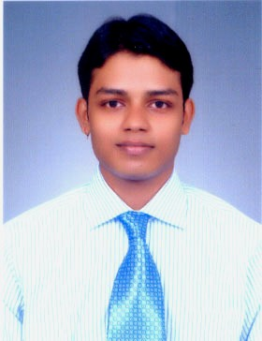

Name : ABIR DAS
Address : 6,KABI SUKANTA SARANI(PURBITA),BIRATI,
KOLKATA-700051
Mobile No :9477454447

E-mail :dasabir303@gmail.com

Academic Qualifications:

Degree / Certificate | Qualification | Institute | Board /  University | Year | Aggregate % / CGPA
Graduation | B.Tech  EIE  (pursuing) | IERCEM INSTITUTE OF INFORMATION TECHNOLOGY | WBUT | 2008-2012 | 7.56
12th | HIGHER SECONDARY | BIRATI HIGH SCHOOL | WBCHSE | 2008 | 69.42
10th | SECONDARY | BIRATI HIGH SCHOOL | WBBSE | 2006 | 78

Trainings / Projects Undertake
Name of Institute / Organization | Project Title | Duration
NATIONAL THERMAL POWER CORPORATION(FARAKKA) | INTRUMENTATION &  CONTROL OF THERMAL POWER PLANT | - MONTH

Subjects of Interest:

- SENSORS & TRANSDUCERS
- MICROPROCESSOR

Computer Proficiency:

- C
Hobbies:

- PLAYING CRICKET
- WATCHING MOVIES
Family Details:

Details | Name | Occupation
Father | BADAL KANTI DAS | BUSINESS
Mother | PRITI KANA DAS | HOUSE WIFE
Siblings | SHARMILA DAS | TEACHER

Personal Details:

Date of Birth :05.01.1990
Gender :MALE
Languages Known : ENGLISH,BENGALI & HINDI

Date : 20.09.2012 Signature :Abir Das

