Curriculum Vitaé

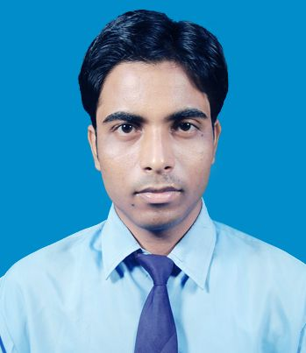
Please affix a
Passport size
photo here

Name : Baloram Chandra Hazra
Address : 256, Sunit Banerjee Road,
P.O :-Ghola Bazar,
Dist:- 24 Parganas(North),
Kolkata-700 111
Mobile No : +91-8961282641
+91-9093981742

E-mail : baloram1989@gmail.com

baloram1989@rediffmail.com

Academic Qualifications:

Degree | Qualification | Institute | Board/university | Marksobtained | Year of passing | DGPA/  CGPA
Graduation | B.Tech  (ECE) | Birbhum  Institute of  Engineering & Technology,  Suri,Birbhum | W.B.U.T | 1st sem=6.77  2nd sem=7.87  3rd sem=7.97  4th sem=8  5th sem=8.08  6th sem=7.93  7th sem=8.15  8th sem=7.83 | 2012 | 7.86
12th | Higher Secondary Education | Netaji Shikshayatan,  Agarpara | W.B.C.H.S.E |  | 2008 | 65.40
10th | Secondary Education | Ghola High School,  Sodepore | W.B.B.S.E |  | 2006 | 73.37

Trainings / Projects Undertaken:

Name of Institute / Organization | Project Title | Duration
Birbhum Institute of Engineering & Technology | A Delay Modeling for Submicron CMOS logic. | 1 year

Subjects of Interest:

- Digital Electronics
- Microprocessors(8085)

Computer Proficiency:

- Programming in C
- Data Structure
- DBMS

Hobbies:

- Playing cricket
- Listening music

Family Details:

Details | Name | Occupation
Father | Mr. Kartick Ch. Hazra | Service holder
Mother | Mrs. Alpona Hazra | Housewife
Siblings | Mr. Krishna Ch. hazra | Service holder

Personal Details:

Date of Birth : 20.11.1989
Gender : Male
Languages Known : Bengali,Hindi,English

Date : Signature
Baloram Ch. Hazra

