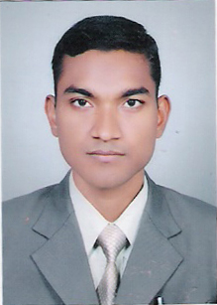
CURRICULUM-VITAE
Muhammad Zakir Ansari
Address : 69, M. B. House,
University of Allahabad
Allahabad
Pin Code -211002
Contact No : 8896298377

CAREER OBJECTIVE :
To serve the organization with constant spirit & motivation while also taking up interesting and innovative tasks that place my career along path with the organization.

EDUCATIONAL QUALIFICATION :
    - Passed High School from C.B.S.E. Board in 2004 with 2nd Division.
    - Passed Intermediate from C.B.S.E. Board in 2006 with 1st Division.
    - Passed Graduation (B.C.A.) from Integral University, Lucknow in 2012 with 1st Division.
COMPUTER SKILL :
- MS-Office, C/C++, Java, DBMS, Visual Basic, DCN, Internet and Web Design.
- Pursuing MCPD (ASP.net) from UPTEC.
- Pursuing ‘A’ Level from DOEACC Society.
STRENGTH :
- Good Communication Skills.
- Positive Attitude.
- Confidence.

PERSONAL INFORMATION :

FATHER'S NAME | : | Mr. Zuber Ahmed Ansari
MOTHER’S NAME | : | Mrs. Habibun -Nisha
DATE OF BIRTH | : | 01/07/1990
GENDER | : | Male
LANGUAGE KNOWN | : | Hindi & English
NATIONALITY | : | Indian
MARITAL STATUS | : | Unmarried

DECLARATION :
I hereby affirm that the particulars Mentioned Above are true and correct to the best of my Knowledge.

Date :
Place : Allahabad (Muhammad Zakir Ansari)

