RESUME
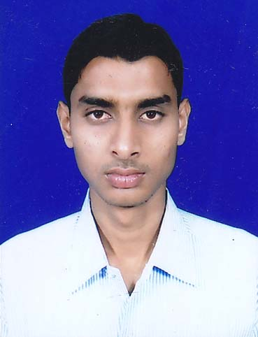

SUDEB MUKHERJEE
Vill+p.o-Hirapur,Burnpur
Dist-Burdwan
Pin-713325

West Bengal, India.

E-mail: sudebmukherjee6@gmail.com

Phone: (+91)8101038385

Objective:

To pursue a successful career and to work in an innovative, competitive and challenging world.

Synopsys:
I have completed my engineering in Computer Science. I have a flair for Technology and I like to explore the depth and breadth of JAVA. My favorite languages are Java ,C . I like to play Badminton and enjoy my leisure time by watching Television and surfing internet.

Technical Exposure:

Subject of Interest Data Structure(using C) ,RDBMS

Languages C , Java

Operating System used Win 07 ,Win XP

Education:

Degree | University / Board | Year of Passing | Institute | % / CGPA
B.Tech | W.B.U.T. | 2012 | B.U.I.E. | 7.28/10
H.S. | W.B.C.H.S.E. | 2008 | BURNPUR BOYS  HIGH SCHOOL | 76.4%
Madhyamik | W.B.B.S.E. | 2006 | SUBHASPALLI  BIDYANIKETAN | 76.12%

Curriculum Project:

Project Title:
- “Bank Management System” in Java from Globsyn Technologies Limited.
Brief Overview Of Project:
The Objective of our project on ”Bank Management System” was to create a standalone system software which can be help full
to any Bank.

ACHIEVEMENTS:

- Received Merit Certificate in Madhyamik from Asansol Municipal Corporation for scoring more than 75% marks.

- Received Merit Certificate in H.S from Asansol Municipal Corporation for scoring more than 75% marks.

---------------------------------------------------------------------------------------------------------

Personal Profile:

Date of Birth: | 12-07-1991.
Sex: | Male
Marital Status: | Single
Languages Known: | English, Hindi and Bengali
Nationality: | Indian
Present Address: | Vill+p.o-Hirapur,Burnpur, Dist-Burdwan,  pin-713325
Permanent Address: | Vill+p.o-Hirapur,Burnpur, Dist-Burdwan,  pin-713325

Declaration:

I hereby declare that the information furnished above is true to the best of my knowledge.

Date:
Place: Sudeb Mukherjee

