CURRICULUM VITAE

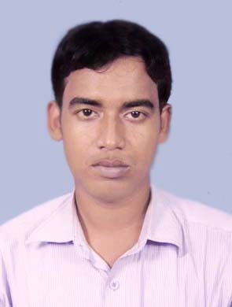
KRISHNASIS MAITY
VILL: - DAKSHIN ARJUNDA
P.O.:- CHAKRADHABAN
P.S. – PANSKURA
DIST: - PURBA MEDINIPUR 0091-9647067239
WEST BENGAL -721152, INDIA 0091-9732736656(Home)
Email ID: krishnasis86@gmail.com, krishnasis14@rediffmail.com, krishnasis86@rocketmail.com

HIGHLIGHTS : An enthusiastic hard worker.
OBJECTIVE : Seeking a position utilizing my technical knowledge
STRENGTH : Hard Working, Strong Determination, Positive Attitude, Flexibility.

Current Profile:
Total experience : - 5 Years, 0 Months.
Previous Employee : - HINDUSTAN CONSTRUCTION COMPANY LTD
Designation : - Data Entry Operator
Current CTC : - IR 2,00,000/ Annum’s
Expectation CTC : - IR 3, 50,000/ Annum’s + Perks

Technical Qualification:

Operating Systems : Windows XP, 2003, 2007.
Subject : Word, Excel, Power Point, Internet.

Job Profile:-

1 Project Detail :

Name of Origination : Sparsh BPO Service Ltd
Duration Period : January 2007 to January 2008
Job Details : As a Data Entry Operator in favour of Reliance General Insurance.
2 project Detail :
Name of Origination : Shell Transourses Pvt Ltd.
Duration Period : Feb 2008 to October 2009
Job Detail : As a Data Entry Operator in favour of Reliance General Insurance.

3 Project Detail :
Name of origination : Vodafone South Essar Ltd
Duration period : November 2009 to November 2010
Job Details : Working as a MIS

4 Project Detail :
Name of origination : Softage Information Technology
Duration period : December 2010 to June 2011
Job Details : As a Data Entry Operator in favour of Vodafone Essar South Ltd.

5 Project Detail : Lower Subansiri Hydro Electric Power Project (2000 MW) India
Name of origination : Larsen & Toubro ECC Division Ltd. (India)
Duration period : June 2011 to November 2011.
Job Details : As a Data Entry Operator.
6 Project Detail : Pare Hydro Electric Power Project (110 MW) India
Name of origination : Hindustan Construction Ltd. (India)
Duration period : November 2011 to April 2012.
Job Details : As a Data Entry Operator.

Educational Qualification:-
Board of Madhyamik and Higher secondary Education, West Bengal
Year 2004 Higher Secondary pass
Year 2002 Madhyamik pass

Personal Details:-

➢ Father’s Name – Late. Nakul Chandra Maity
- Date of Birth – 14 May 1986
- Blood Group – B+.
- Nationality – Indian.
- Religion – Hindu.
- Marital Status – Single.
- Language known – Hindi, Bengali

Communication address – C/O:-Chandi Charan Maity VILL+PO- AMLAGORA, PS- GARBETA, DIST- PASCHIM MEDINIPUR, PIN NO – 721121 (W.B.)

......................................

(KRISHNASIS MAITY)

