**BIO-DATA**



1. Name : Ranjit Mondal
2. Father’s Name : Narayan Mondal
3. Date of Birth : 13/12/1988
4. Permanent Address : Vill- Mondira, Post- Panuria

PS- Barabani, Dist- Burdwan

West Bengal, 713315

Cont. No:- 8001767721, 8001242087

1. Present Address : Do,
2. Nationality : Indian
3. Cast : Gen
4. Religion : Hinduism
5. Gender : Male
6. Education Qualification : H.S. Pass
7. Extra Qualification : Computer( DITA, D.T.P, Hardware &

Networking Etc.)

1. Experience : 1) 8 Month Magus Customer Care (Kolkatta)

2) 1Years 9 Months Teacher (Ankur Computer Centre)( Gourangdi)

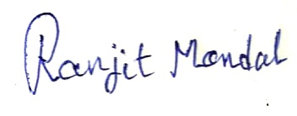

Date. 05-06-2013

Place. Mondira Signature