[Type a quote from the document or the summary of an interesting point. You can position the text box anywhere in the document. Use the Text Box Tools tab to change the formatting of the pull quote text box.]

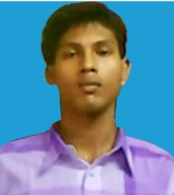

Objective:To convey my service for an organization where my

skill can be utillized for the betterment of the organization with

the job satisfaction

.**NAME-**SANTU BERA

**FATHER’S NAME-**BASUDEB BERA

**DATE OF BIRTH-**2th,MAY,1992

**SEX&MARTIAL-**MALE, UNMARRIED

**RELEGION-**HINDUISM

**NATIONALITY KNOWN-**BENGLI, HINDI, ENGLISH

**PRESENT&PARMANENT ADDRESS-**

GOURIPUR,ULUBERIA,HOWRAH

**PIN-**711315

***MOBILE NO-9038630345***

**Academic Qualification**

10th passed from W.B.B.S.E in the year of 2008

12th passed from W.B.C.H.S.E in the year of 2010

**Technical knowledge -**

Installation xp,vista,windows7,server2003,server2008,

Assembling.

Place-uluberia

Date-9.7.13

**SANTU BERA**